Picosecond transient photoconductivity in organic molecular crystals

Frank A. Hegmann^{*a}, Oksana Ostroverkhovaª, Jianbo Gaoª, Lloyd Barkerª, Rik R. Tykwinski^{b},
John E. Bullock^{c}, and John E. Anthony^{c}

ªDepartment of Physics, University of Alberta, Edmonton, Alberta, Canada T6G 2J1
^{b}Department of Chemistry, University of Alberta, Edmonton, Alberta, Canada T6G 2G2
^{c}Department of Chemistry, University of Kentucky, Lexington, Kentucky 40506-0055

ABSTRACT

We examine ultrafast photoconductivity in functionalized pentacene single crystals using optical-pump terahertz-probe techniques. The 0.5 ps rise time observed in the photoconductive transients, which is limited by the response time of the terahertz pulse setup, suggests that mobile charge carriers are a primary photoexcitation. The peak of the photoconductive signal increases as the temperature decreases due to higher carrier mobilities at lower temperatures. A lower limit for the carrier mobility of 1.6 cm²/Vs at 10 K and 0.2 cm²/Vs at room temperature is obtained. We further show that the absorption edge near the pump excitation wavelength of 800 nm remains temperature independent, and is therefore not a contributing factor in our observation of larger transient signals at lower temperatures. After an initial fast decay, a power-law decay is observed in the tail of the transient response from 2 to 600 ps. The dependence of the photoconductive response on the pump fluence and the electric field amplitude of the terahertz pulse are examined. Finally, we show some preliminary results of transient photocurrent measurements on contact-biased samples using a fast oscilloscope with a system rise time of about 50 ps.

Keywords: terahertz pulses, ultrafast, organic molecular crsytals, pentacene, transient photoconductivity, primary photoexcitations, carrier dynamics, mobility, organic semiconductors

1. INTRODUCTION

There is growing interest in organic materials for applications in electronic and photonic devices. Pentacene organic thin film transistors (OTFTs) have been studied extensively due to their relatively high carrier mobility at room temperature (compared to polymers) on the order of 0.1 – 1.5 cm²/Vs and for their potential use in flexible organic circuits.¹⁻⁴ Field-effect transistors (FETs) on rubrene and tetracene single crystals have also been studied, but the reported mobility was still less than 1 cm²/Vs at room temperature.⁵⁻⁷ The carrier mobility of pentacene thin film OTFT devices typically decreases or remains constant as the temperature is lowered.¹ On the other hand, time-of-flight (TOF) experiments on ultrapure single crystals have revealed carrier mobilities that increase as the temperature is decreased consistent with band-like transport observed in many inorganic semiconductors,⁸⁻¹⁰ but this behavior is not completely understood in organic crystals.¹⁰⁻¹³ For example, ultrapure naphthalene single crystals have a hole mobility that increases from about 1 cm²/Vs at room temperature to more than 100 cm²/Vs below 30 K.^{9,10} Recent transport measurements on high-purity tetracene single crystals have also shown an increase in carrier mobility as the temperature is lowered below 300 K.⁸ There is also much interest in organic materials for light-emitting devices,^{14,15} lasers,^{16,17} solar cells,^{18,19} and photodetectors.¹⁹⁻²² In fact, a photodetector structure with sub-nanosecond response time and 75% quantum efficiency in the visible region has been demonstrated.^{19,20}

However, despite the many advances in organic electronics and photonics, the nature of photocarrier generation and transport in organic semiconductors is not completely understood and remains controversial even today.²³⁻²⁵ The generation of mobile charge carriers in photoexcited organic materials occurs over femtosecond to picosecond time scales, and so ultrafast pump-probe experiments are essential in order to address this controversy and improve our understanding of fundamental processes in these materials. Many ultrafast studies on polymer materials support the molecular exciton model where the primary photoexcitations are strongly bound excitons which can dissociate into separated mobile charge carriers under the influence of an external electric field.²⁶⁻³⁰ Some of these studies demonstrate that the creation of free charge carriers by electric-field-assisted dissociation of excitons occurs over time scales as long as 10 to 100 ps.^{27,28} The primary photoexcitations in organic molecular crystals are also believed to be tightly bound excitons (or Frenkel excitons).^{11,31} On the other hand, several other experiments have supported the semiconductor band model where the primary photoexcitations are mobile charge carriers created directly from the light absorption process. One of the characteristic signatures is therefore a rapid onset of mobile charge formation in zero external electric field over sub-picosecond time scales, as observed in some studies on polymer samples^{32,33} and more recently in terahertz pulse experiments (discussed below) on organic cyrstals.^{34,35} One of the unique advantages of terahertz pulses as a probe of carrier dynamics in organic materials is that terahertz pulses are sensitive to mobile charge (i.e. photoconductivity), rather than just the presence of charge carriers as is often probed by all-optical techniques. This paper describes some of these terahertz pulse experiments performed on functionalized pentacene single crystals.³⁴ More direct measurements of the transient photoconductivity using contact-biased samples and a fast oscilloscope are also useful for understanding the nature of photoexcitations and charge transport in organic materials.³⁶⁻³⁹ Some preliminary results on contacted, voltage-biased, functionalized pentacene crystals are also given.
* hegmann@phys.ualberta.ca ; Phone: (780) 492-7852; Fax: (780) 492-0714.

2. TERAHERTZ PULSEs AND EXPERIMENTAL SETUP

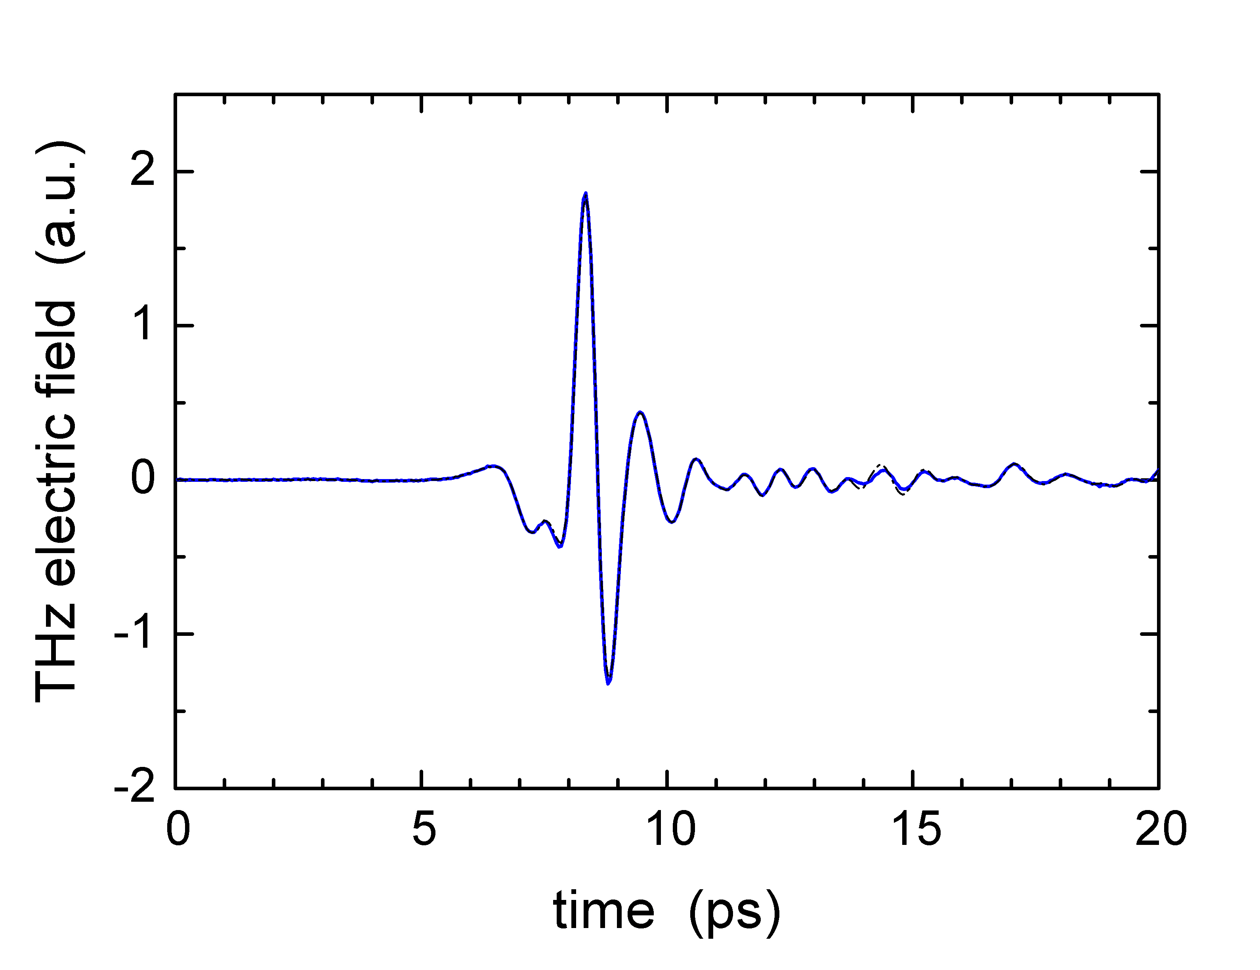
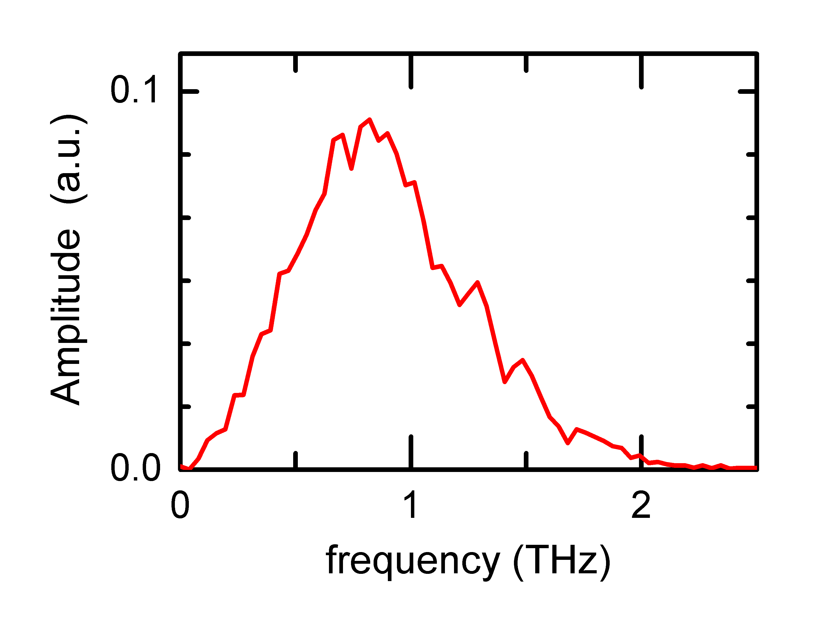
A terahertz pulse can be described as an approximately single-cycle electromagnetic transient with a duration on the order of 1 ps. The corresponding frequency spectrum associated with the terahertz pulse is therefore centered at about 1 THz with a width of about 1 THz, hence the name “terahertz pulse”. An example of a typical terahertz pulse used in our experiments is shown Fig. 1(a), with the corresponding frequency spectrum in Fig. 1(b). A terahertz pulse therefore has wavelength components in the far-infrared region of the spectrum, which makes it ideal for probing the nature of conductivity in a wide variety of materials,^{40,41} including organic materials.⁴²⁻⁴⁴ The characteristics of terahertz pulses generated from nonlinear organic crystals and biased polymer samples has also been used to study the nature of carrier transport in organic materials.⁴⁵⁻⁴⁷
(a)
(b)

Fig. 1. (a) Example of a terahertz (THz) pulse. This particular THz pulse was measured after passing through our optical cryostat and a 1-mm-diameter aperture at the sample holder. (b) Corresponding frequency spectrum.

However, the short duration of terahertz pulses enables sub-picosecond measurements of transient conductivity in materials. For example, transient photoconductivity measurements with sub-picosecond time resolution using terahertz pulses have been performed in GaAs,^{48,49} LT-GaAs,^{50,51} radiation-damaged silicon-on-sapphire,⁵² sapphire,⁵³ as well as organic crystals.^{34,35} Figure 2(a) shows a typical optical-pump terahertz-pulse-probe setup, and Fig. 2(b) describes how the transient photoconductivity induced by the pump pulse in the sample results in a reduction in transmission T of the terahertz probe pulse. It can be shown that the negative of the differential transmission, ΔT = T – T₀, normalized to the initial (unexcited sample) transmission T₀, is proportional to the conductivity σ induced by the pump pulse in the sample for low mobility samples and for |ΔT/T₀| < 25% (i.e. σ = neμ ∝ -ΔT/T₀, where n is the carrier density and μ is the carrier mobility).⁵²

The samples were mounted on a 1-mm-diameter aperture in a liquid helium cooled optical cryostat (sample in vapor) with fused silica windows, as shown in Fig. 3. A 1-kHz repetition rate (1080 Hz), amplified Ti:sapphire laser system generating 100 fs pump pulses at wavelengths of 800 or 400 nm was used to excite the samples. Further details of the setup can be found in Ref. 52. Incident pump fluences at 800 nm on the samples were around 2.5 mJ/cm², which, in a 1-mm-diameter aperture, corresponds to a pulse energy of 20 μJ and an average power of 22 mW. The optical penetration depth for the 800 nm pump pulses was estimated to be about 120 μm in the functionalized pentacene crystals, resulting in carrier densities of 10¹⁷ – 10¹⁸ cm⁻³, or sheet densities of 10¹⁵ – 10¹⁶ cm⁻² (assuming 100% Q.E.).

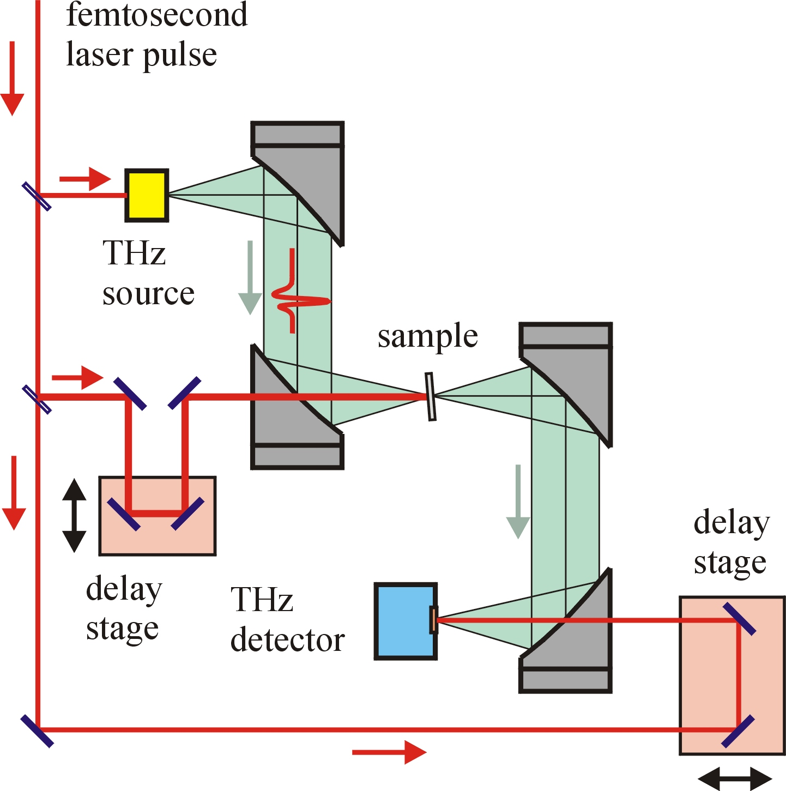
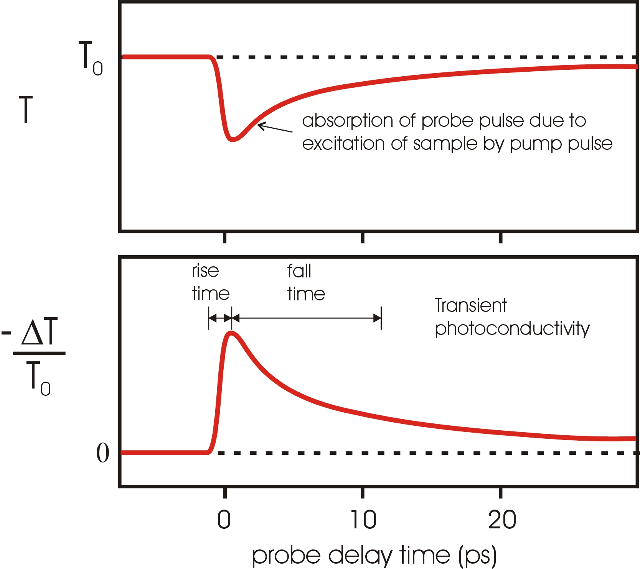
(a)
(b)

Fig. 2. (a) Schematic of the THz pulse setup. One delay stage allows scanning of the THz pulse itself, and the other changes the delay between the THz probe pulse and the excitation pump pulse. (b) Reduction in transmission T of the THz probe pulse as the sample is excited by the pump pulse. –ΔT/T₀ is the normalized negative differential transmission of the photoexcited sample.

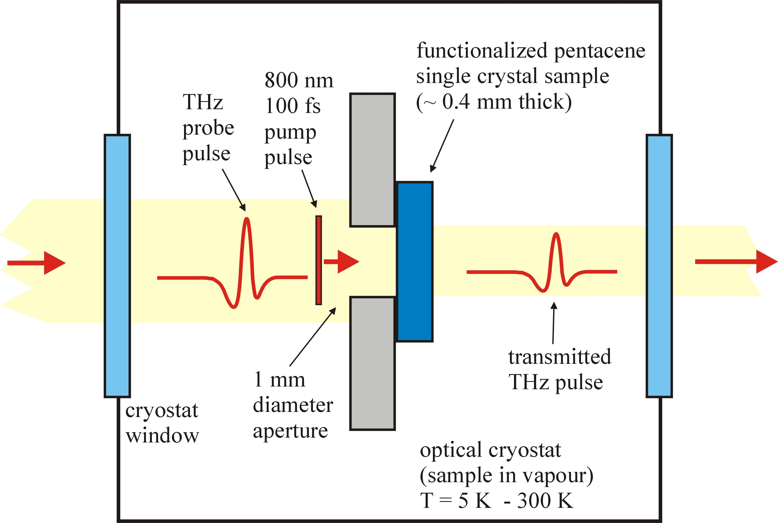

Fig. 3. Schematic of the sample mounted on a 1-mm-diameter aperture in the optical cryostat (sample in vapor). The aperture ensured proper overlap between the focused THz probe pulse and the 800 nm (or 400 nm) pump pulse. The sample temperature could be varied from 5 to 300 K.
3. FUNCTIONALIZED PENTACENE SINGLE CRYSTALS

The functionalized pentacene (FPc) molecule is shown in Fig. 4(a), and is referred to as “TIPS pentacene” due to the triisopropylsilyl side groups.^{54,55} These side groups force the molecules to stack more closely in the crystalline state, as shown schematically in Fig. 4(b), compared to the more open herringbone structure associated with pristine (non-functionalized) pentacene (Pc) crystals. The enhanced π-stacking, which results in higher conductivity in the ab-plane⁵⁴, can be seen more readily in the view down the c-axis in Fig. 4(c), while the effect of the TIPS side groups on the anisotropy of the crystal is evident in the view down the a-axis seen in Fig. 4(d). In the experiments reported here, the pump pulse and the THz probe pulse were at normal incidence to the ab-plane of the crystals so that the electric field of the THz pulse was polarized within the ab-plane. The crystals used in our experiments were grown from solution³⁴ and were typically a few millimeters in size along the a and b axes and about 0.5 mm thick along the c-axis direction. An example of a TIPS single crystal is shown in Fig. 4(e). Further details on the synthesis and crystal structure of functionalized pentacene can be found in Refs. 54 and 55. Low-frequency photoconductivity measurements on TIPS pentacene crystals using biased contacts have been reported by Tokumoto et al.,⁵⁶ and OTFT devices using TIPS pentacene thin films have been made recently with mobilities up to 0.4 cm²/Vs at room temperature.⁵⁷ Band structure calculations on TIPS pentacene have also been reported.⁵⁸ The band gap of TIPS pentacene is estimated to be about 0.6 eV,⁵⁴ which is much smaller than the band gap of about 2.2 eV for pentacene single crystals.¹²
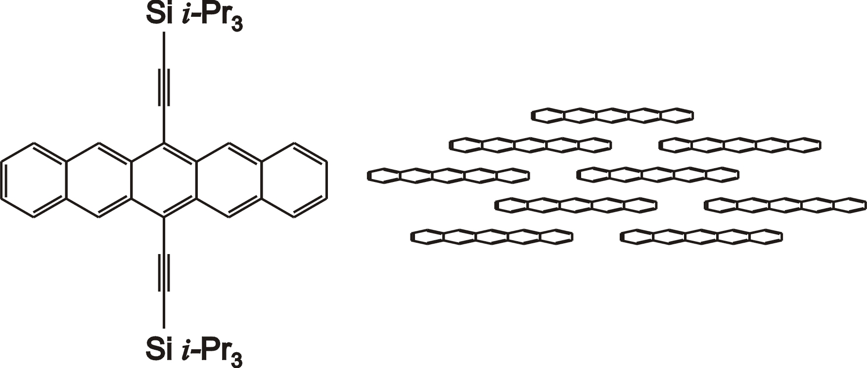
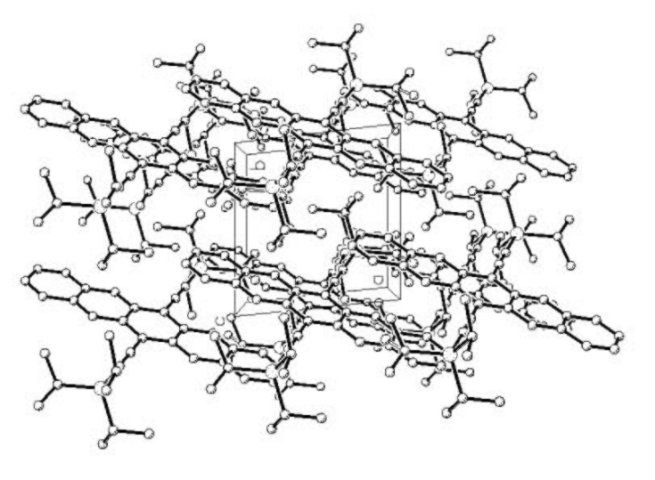
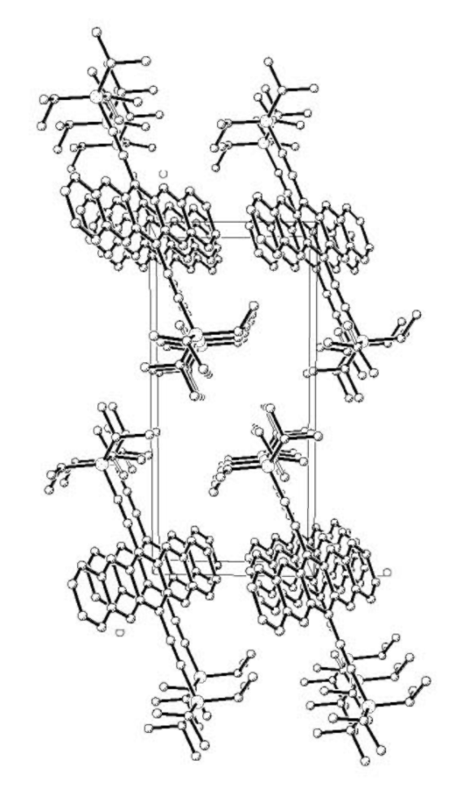
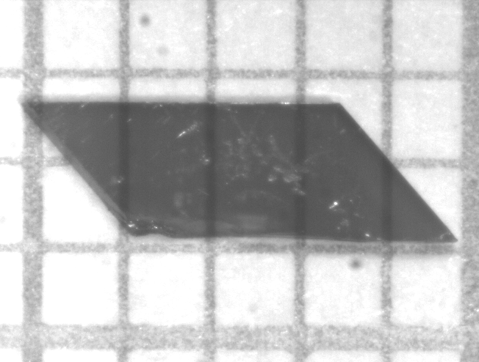
(a)
(b)
(c)
(d)
(e)

Fig. 4. (a) Molecular structure of functionalized TIPS pentacene.
(b) Schematic of stacking of TIPS pentacene in ab-plane. The THz pulse
electric field is polarized in the ab-plane of the crystal.
(c) Crystallographic view of ab-plane looking down the c-axis.
(d) Crystallographic view of bc-plane looking down the a-axis.
(e) Photograph of TIPS single crystal. (Grid spacing = 1 mm.) Note that the apparent transparency of the crystal is due to sensitivity of the CCD camera to wavelengths higher than the absorption edge of the crystal near 800 nm.

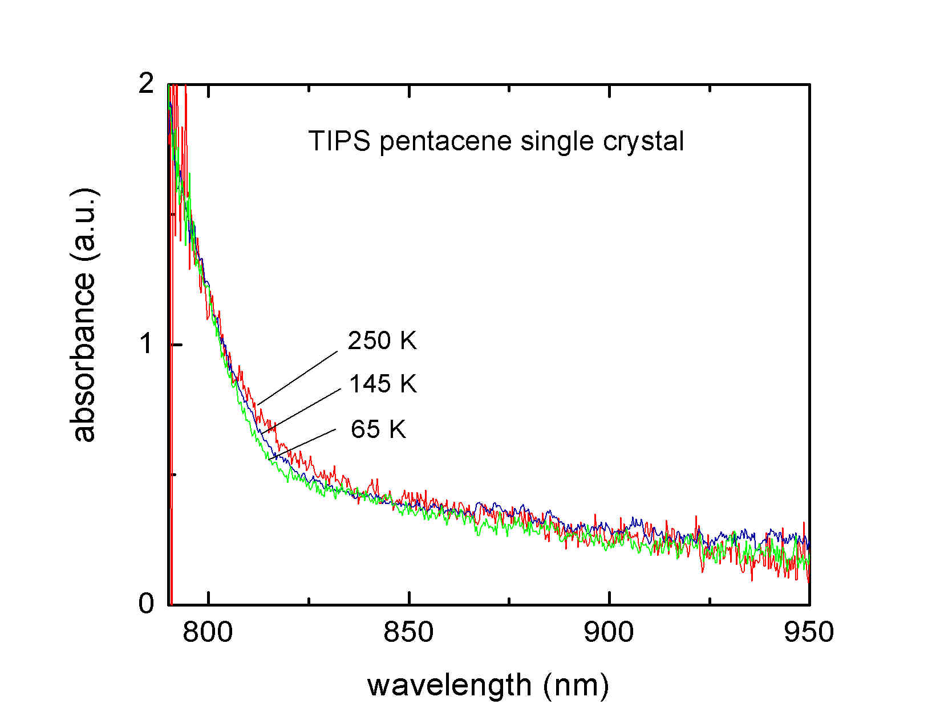
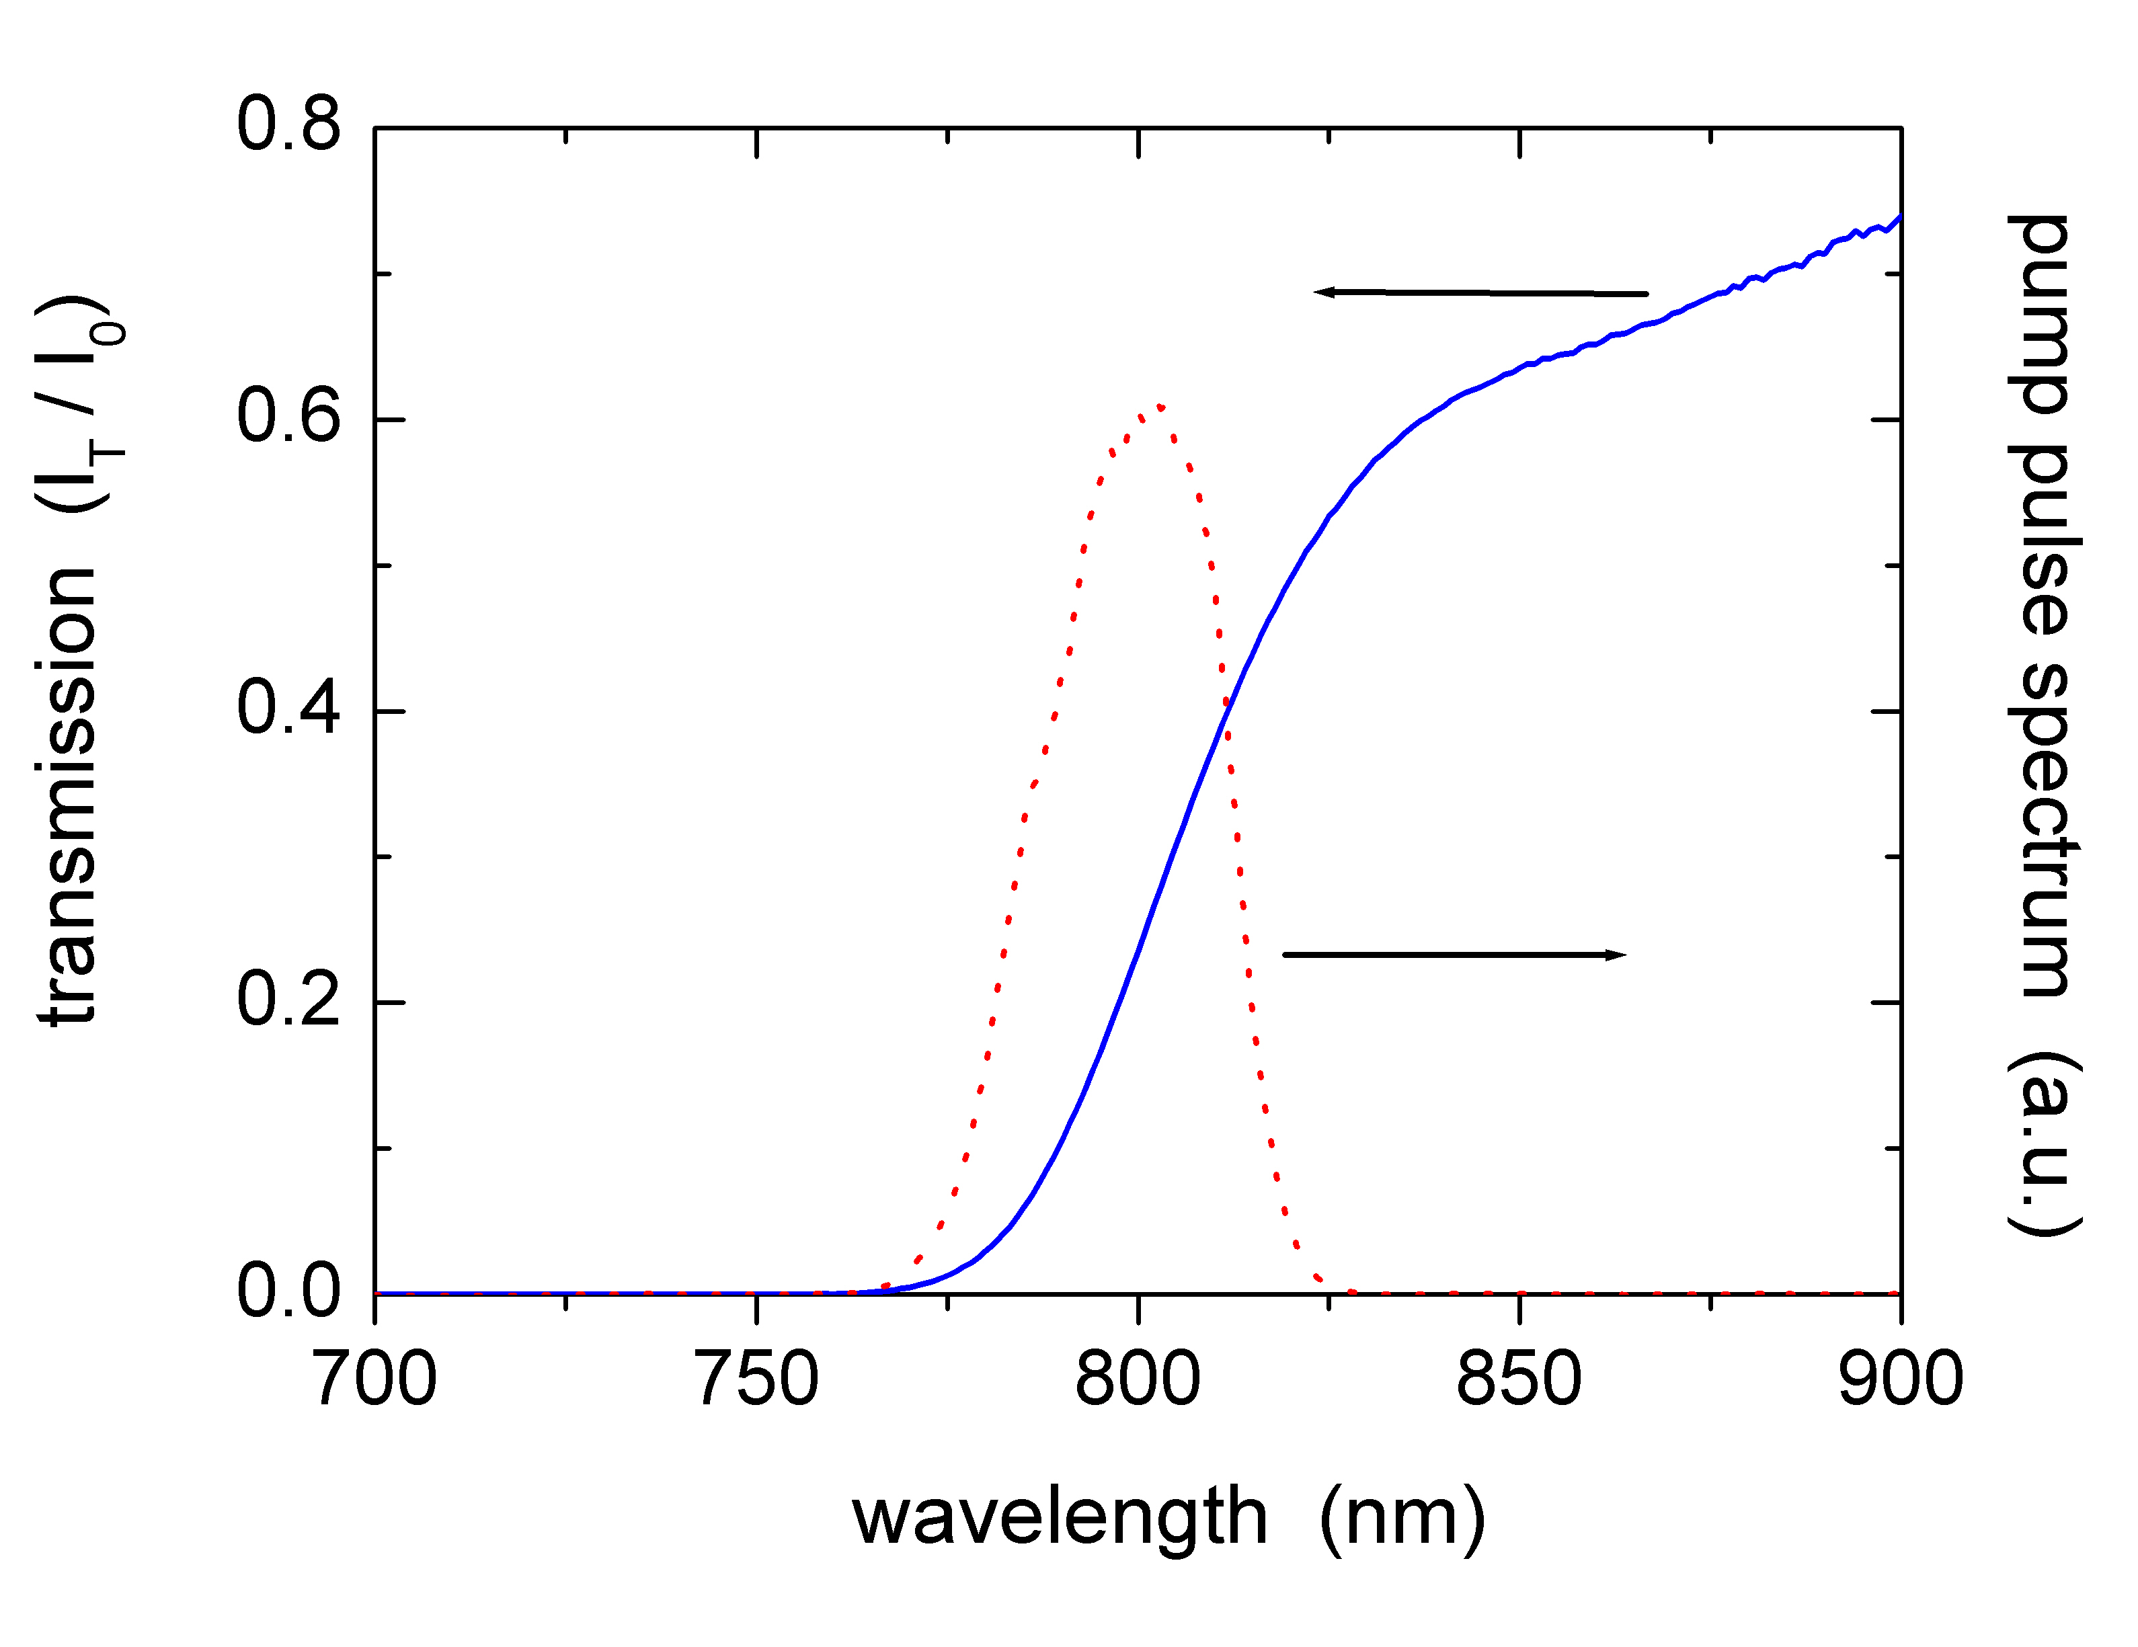
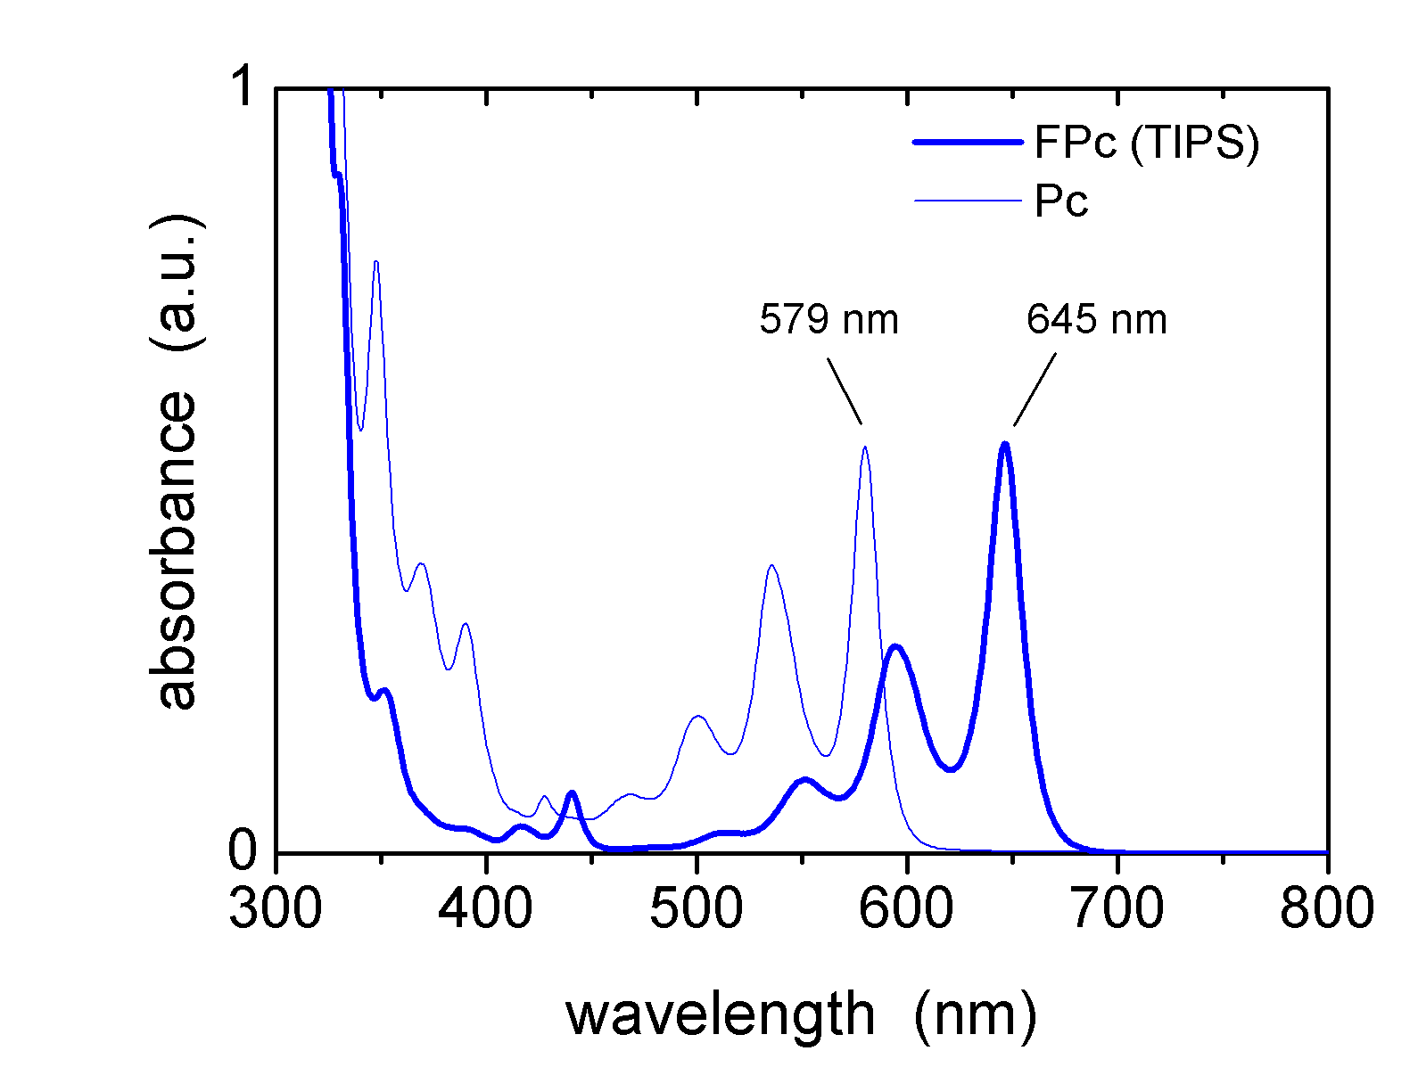
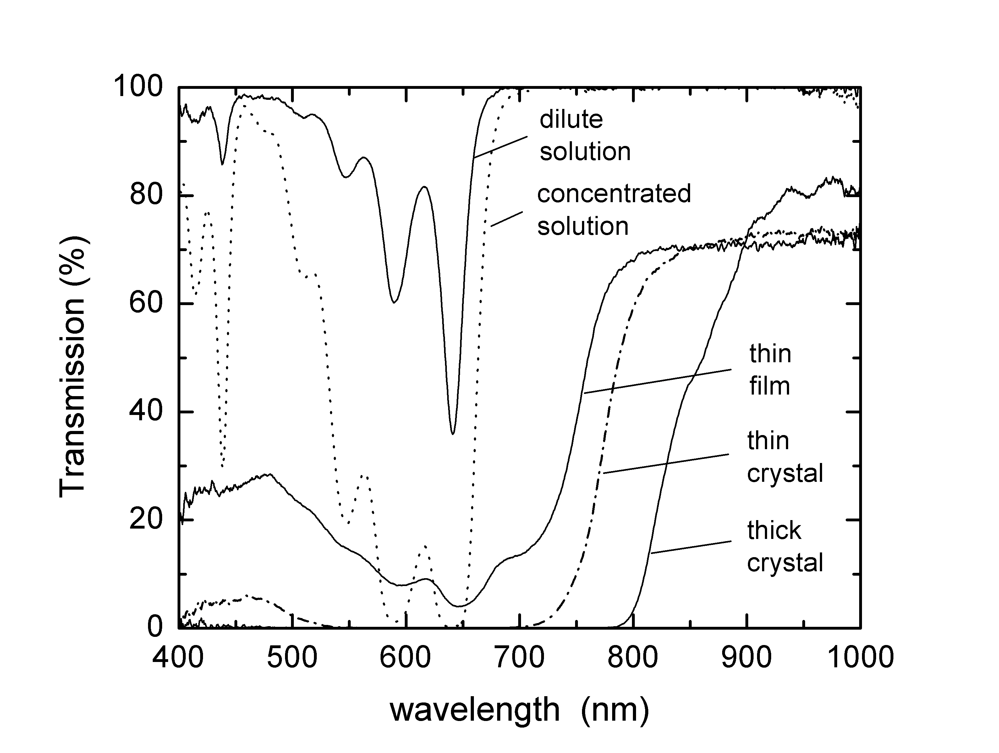
The first optical absorption peak of isolated TIPS pentacene molecules in solution is shifted to lower energies (645 nm) compared to non-functionalized pentacene (579 nm), as shown in Fig. 5(a). However, the absorption edge of a TIPS pentacene thin film left after the solvent evaporated has an absorption edge at even lower energies closer to 750 nm, as shown in Fig. 5(b). A thin crystal platelet has roughly the same absorption edge, whereas a thick single crystal has an absorption edge around 800 – 850 nm. The reason why this absorption edge near 800 nm in the single crystal is so much lower in energy than the first absorption peak at 645 nm in solution not clear. The overlap of the 800 nm pump pulse spectrum with the 800 nm absorption edge of a TIPS single crystal is shown in Fig. 5(c). Furthermore, this feature does not shift significantly from 65 K to 250 K, as shown in Fig. 5(d). This implies that the temperature dependence of the transient photoconductivity data (discussed below) using 800 nm pump pulses is not due to any temperature-dependent shift in the energy of this absorption edge in the crystal.
(a)
(c)
(d)
(b)
Fig. 5. (a) Comparison of optical absorption of FPc and Pc molecules in chlorobenzene. (b) Transmission spectra of TIPS pentacene in dilute and concentrated solutions, as a thin film, a thin crystal platelet, and as a thick single crystal. (c) Spectrum of the 800 nm pump pulses overlapped on the transmission spectrum of a TIPS single crystal near the 800 nm absorption edge. (d) The absorption edge in a TIPS single crystal near 800 nm is nearly temperature independent from 65 K to 250 K.

4. RESULTS AND DISCUSSION

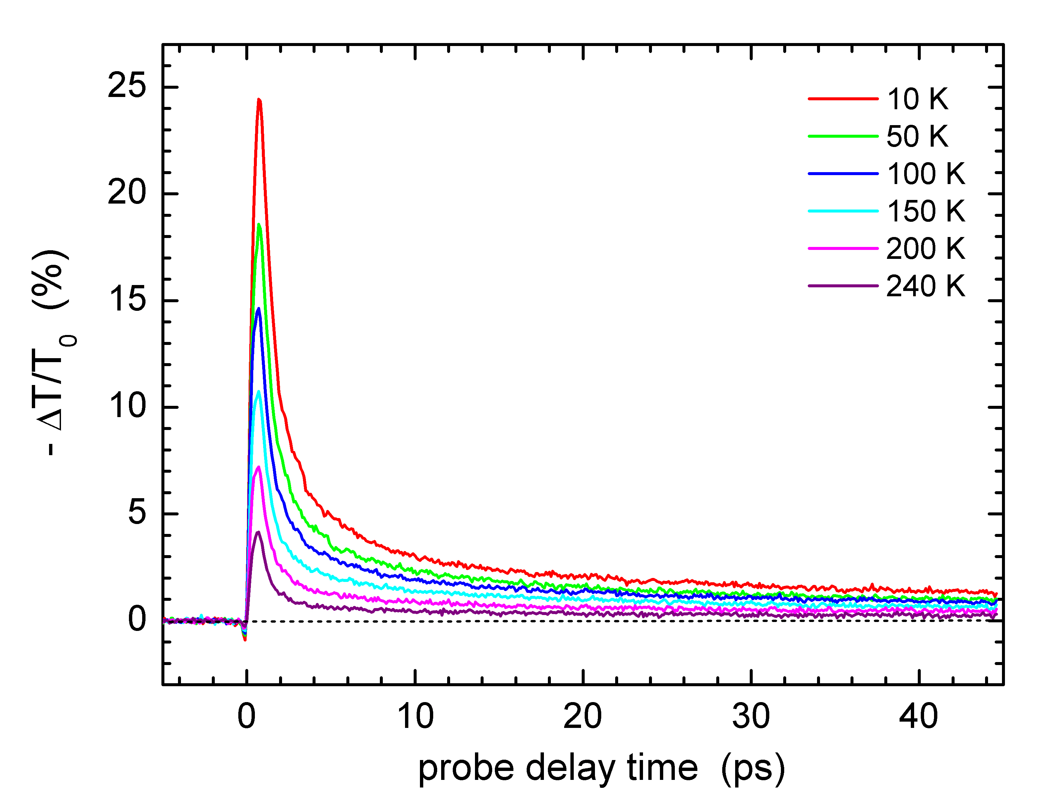
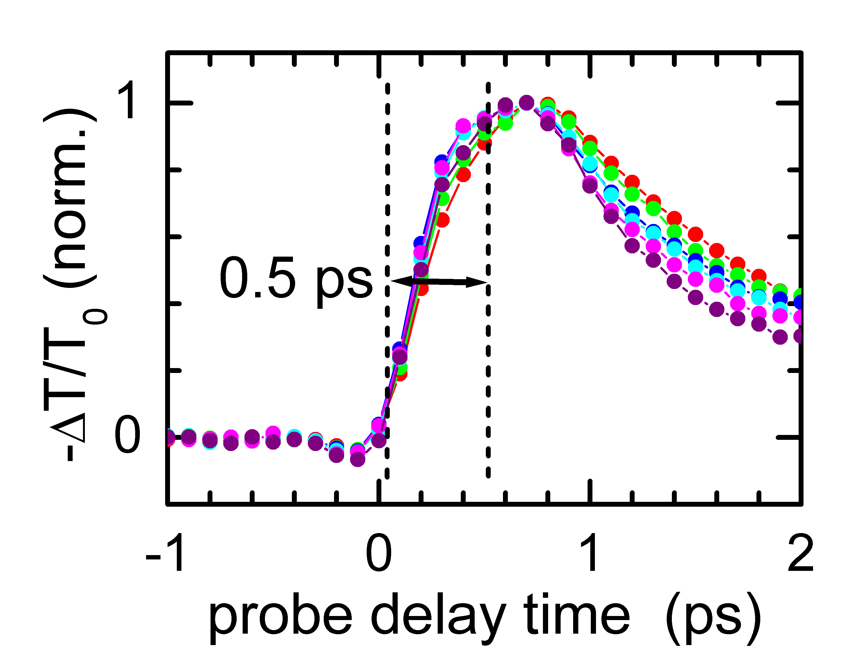
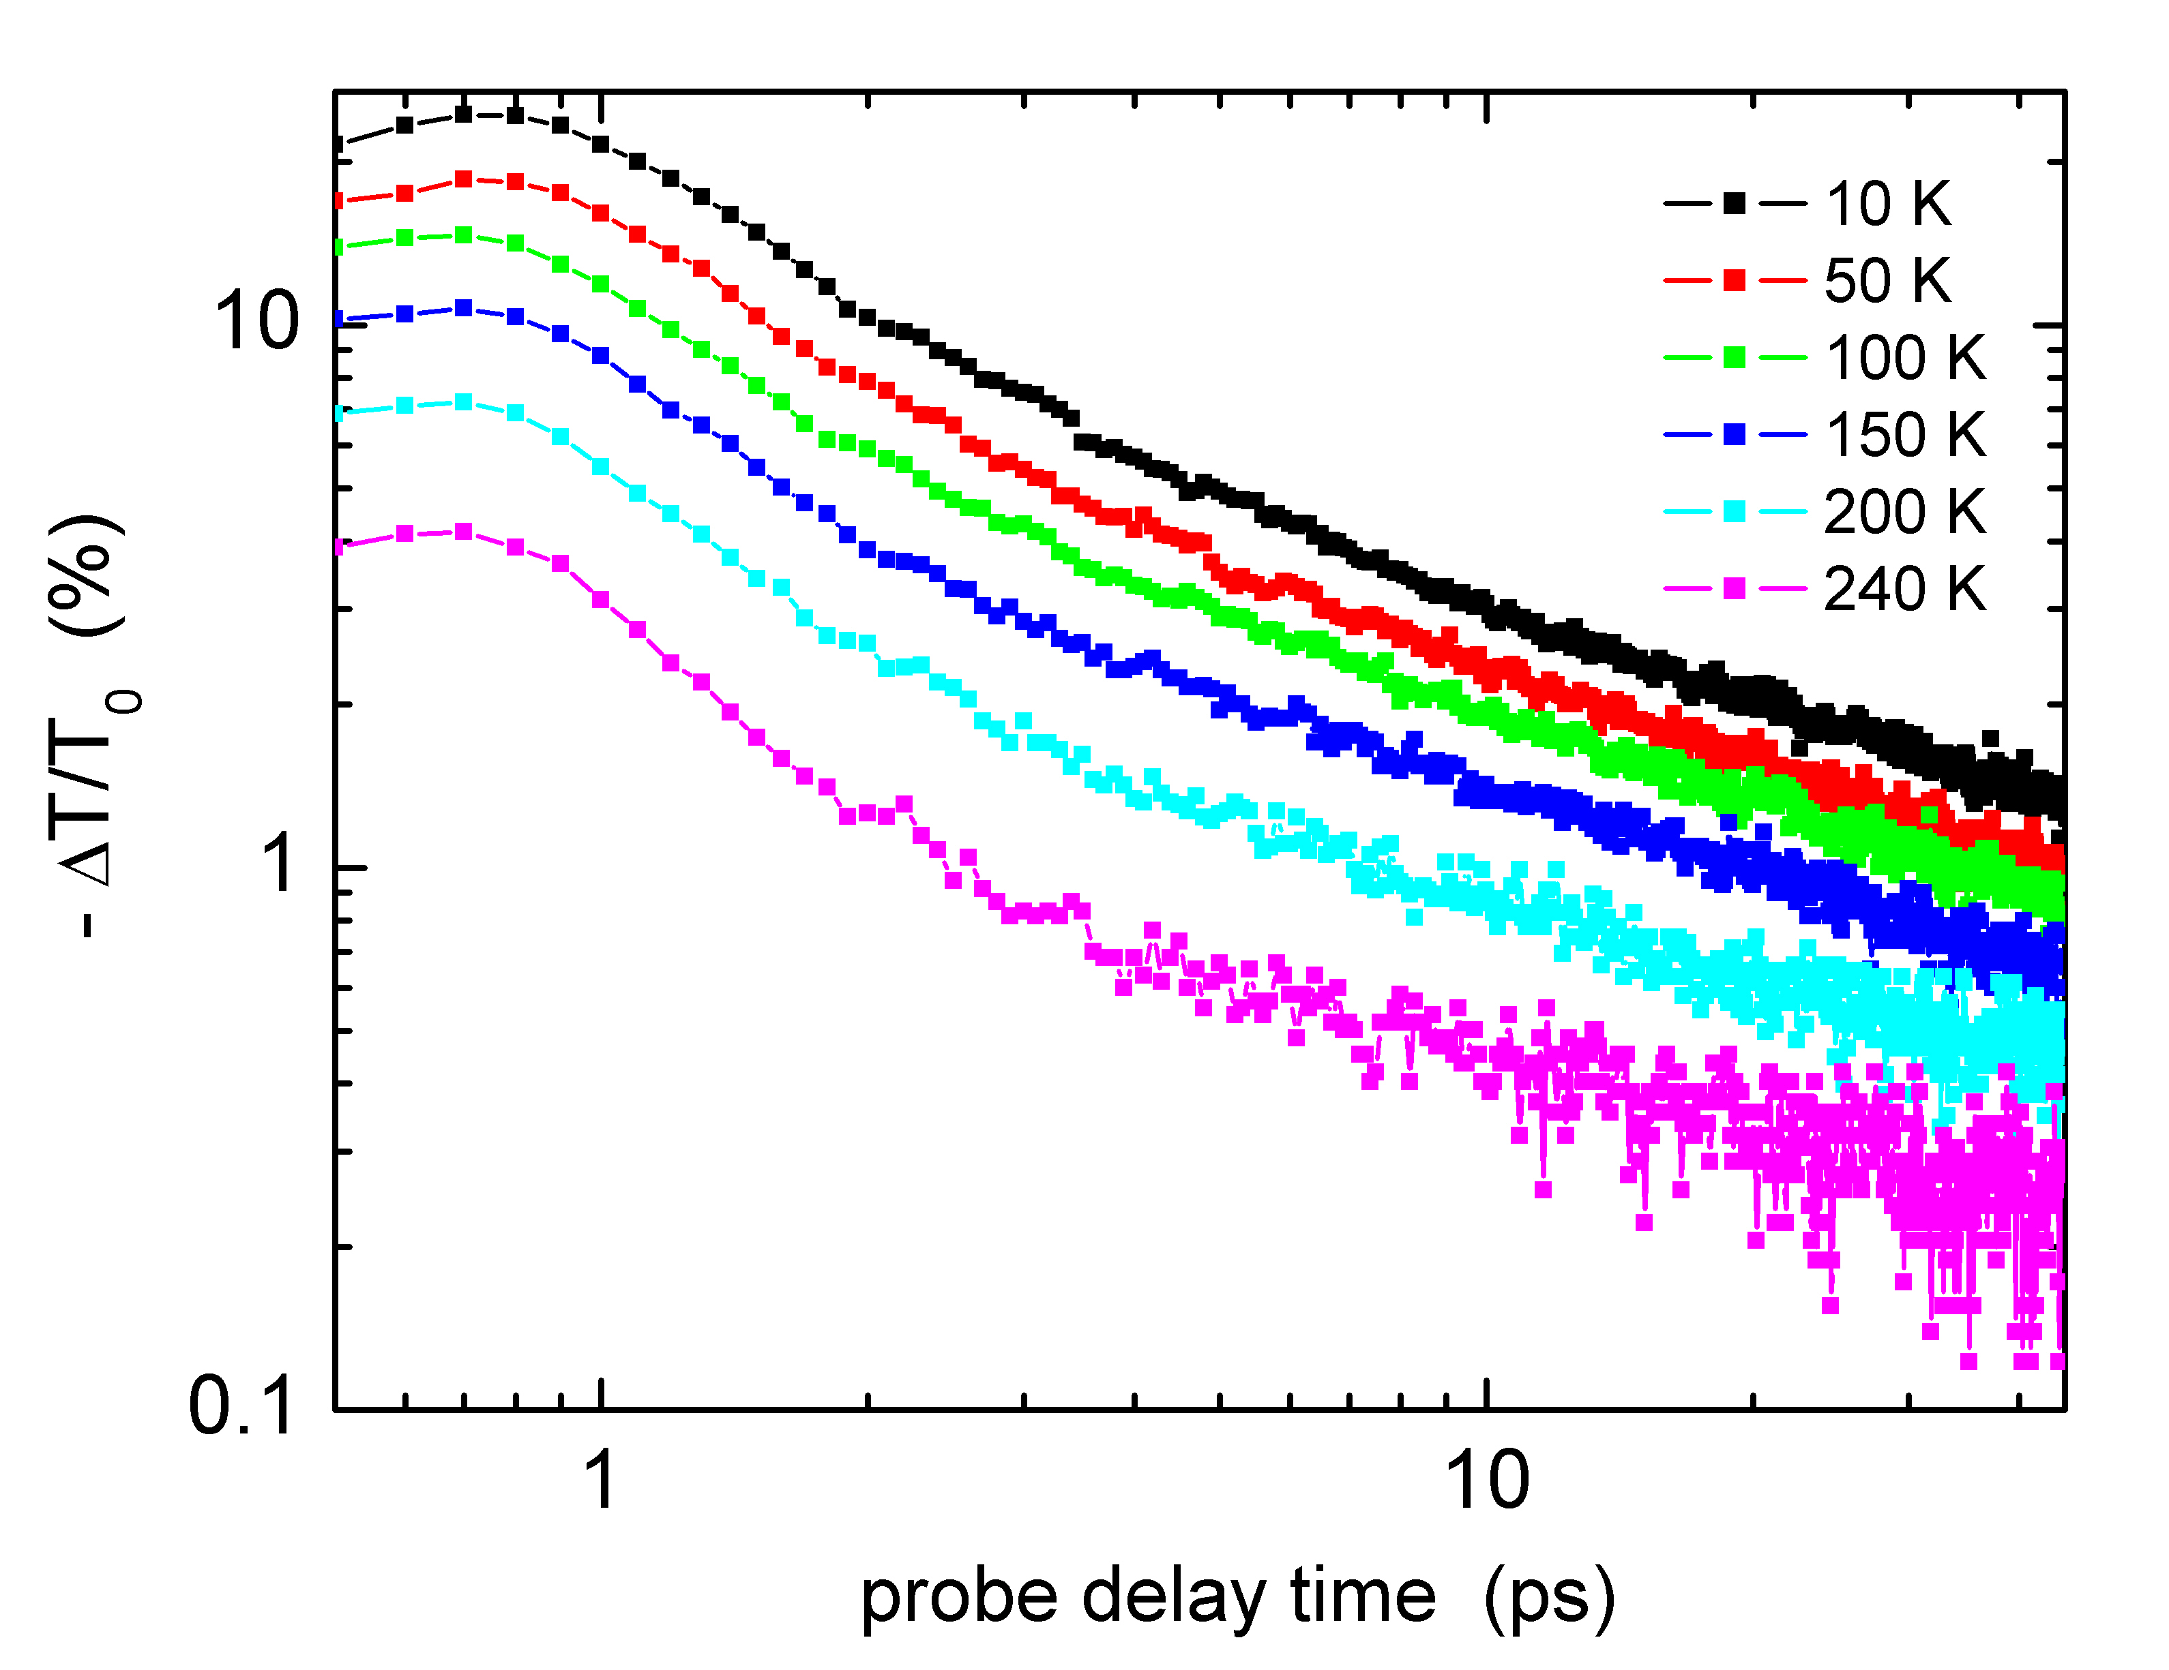
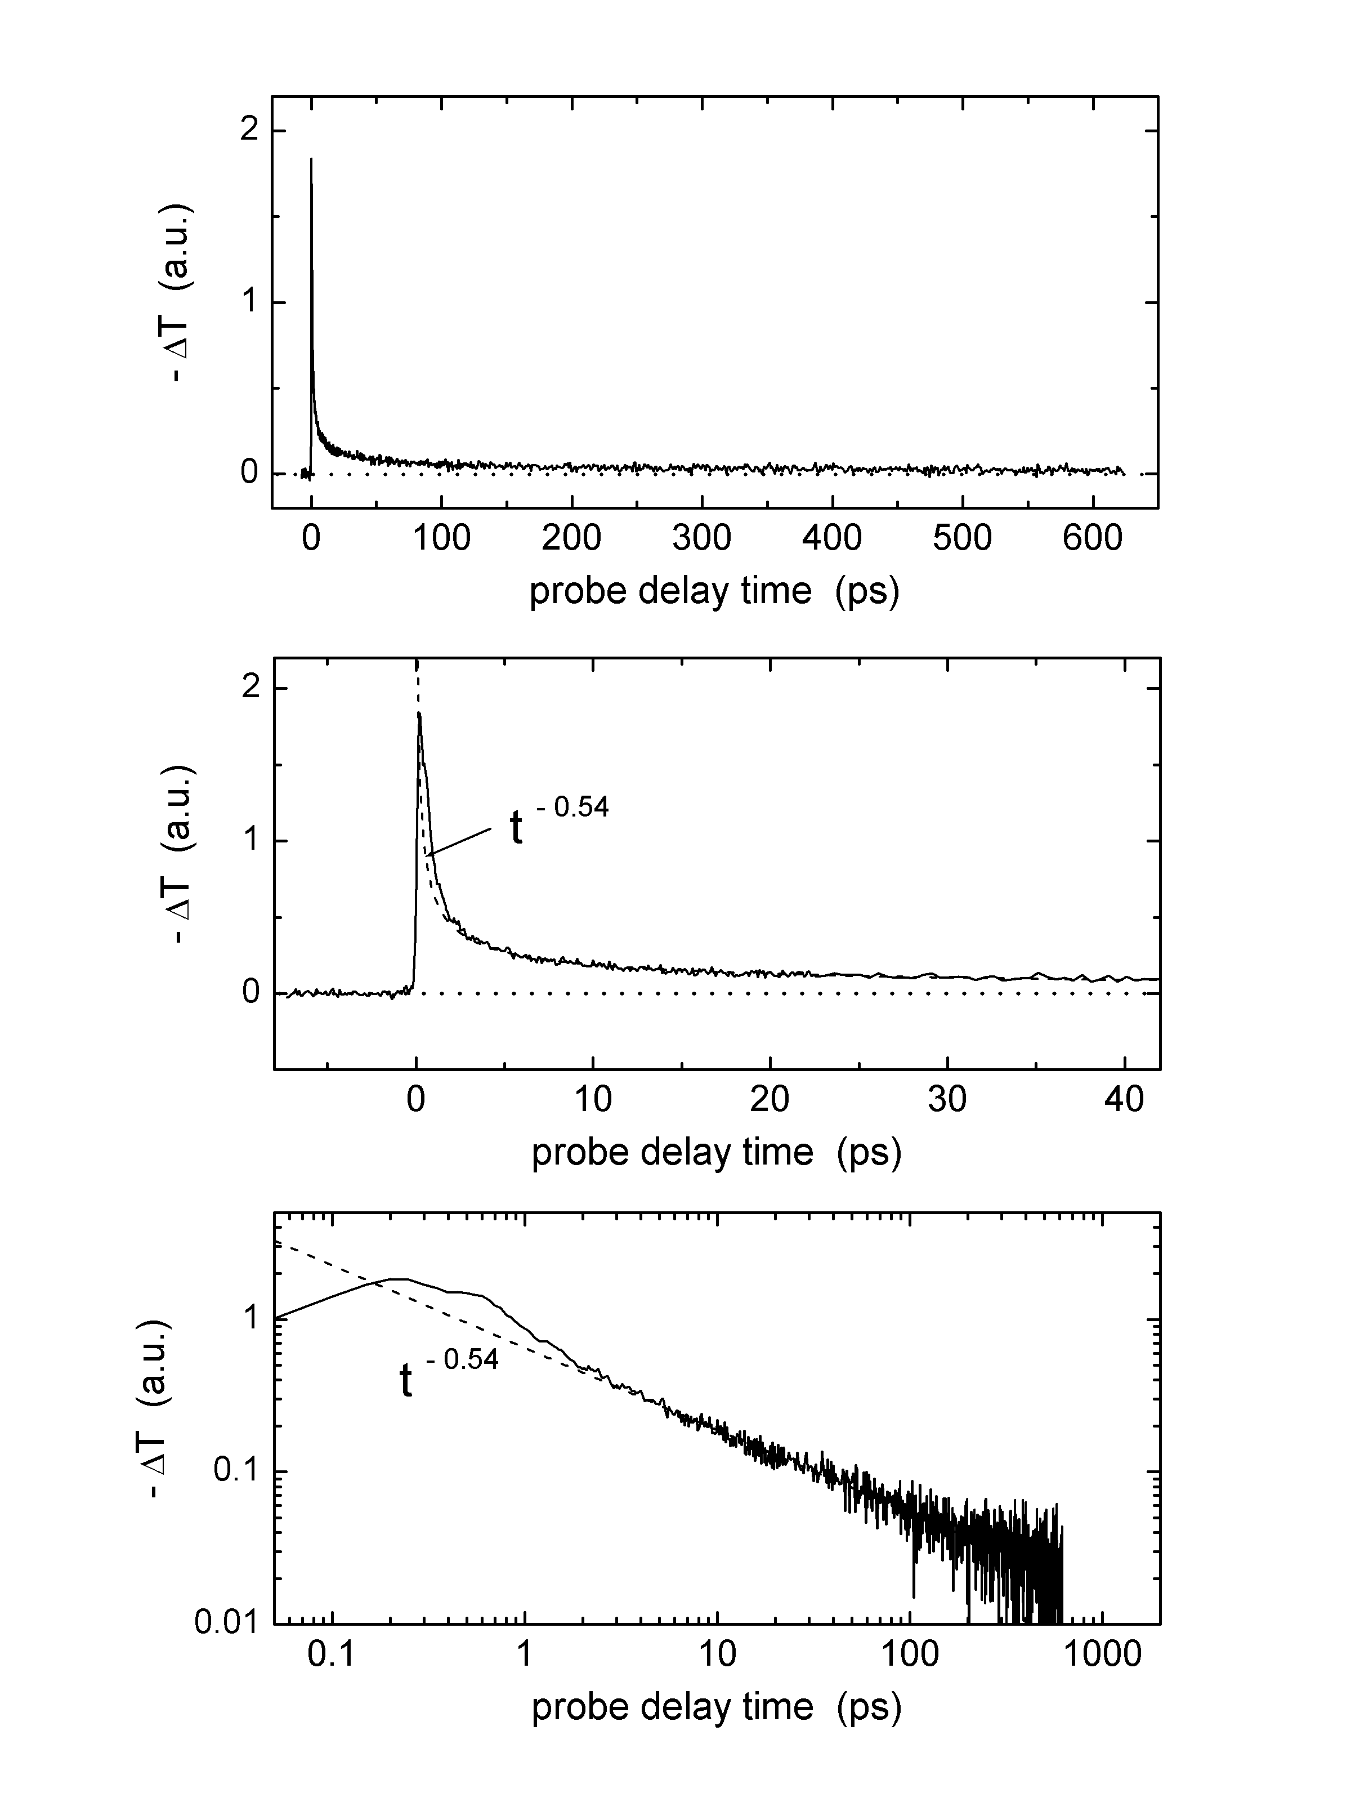
The transient photoconductivity in a TIPS pentacene single crystal that is excited with 800 nm pulses and probed with time-delayed terahertz pulses is shown in Fig. 6(a) for various temperatures. In these measurements, the THz pulse delay stage (see schematic in Fig. 2(a)) was set to monitor the amplitude of the main positive peak of the THz pulse transmitted through the sample, as shown in Fig. 1(a). The pump delay stage was then moved to vary the time delay between the pump pulse and the peak of the THz probe pulse. No phase shift of the THz probe pulse through the sample was observed when the TIPS crystal was photoexcited by the pump pulse.³⁴ This means that the technique of simply monitoring the peak transmission T of the THz probe pulse for measuring transient photoconductivity in these organic crystals is valid. (As mentioned above, the transient photoconductivity in the sample is proportional to the negative differential transmission -ΔT/T₀ of the terahertz probe pulse.) Note that in Fig. 6(a) the magnitude of the transient photoconductivity signal increases as the temperature decreases. The rapid, 0.5 ps (10% - 90%) rise in the signals at all temperatures is limited by the time resolution of the terahertz pulse setup, as shown in the inset of Fig. 6(a).
(a)
(b)
(c)
(d)
(e)
Fig. 6. (a) Transient photoconductivity signals as a function of temperature from a TIPS pentacene single crystal excited by 800 nm, 100 fs pump pulses (2.5 mJ/cm² in a 1-mm-diameter aperture). The peak of the signal increases as the temperature decreases. The inset shows the 0.5 ps rise time (10% - 90%) of the signals limited by the time resolution of the terahertz pulse setup. (b) Log-log plot of the data from (a), showing a power-law decay for the transient photoconductivity signals for times longer than about 4 ps. (c) Long time scan (650 ps) of the transient photoconductivity in a TIPS pentacene single crystal excited by 400 nm pump pulses at 80 K. (d) Expanded view of the same signal in (c). (e) Log-log plot of the data shown in (c). The dashed line is a power-law fit to the data from 2 to 80 ps of the form – ΔT = A t ^{-0.54} , where A is a constant and t is the delay time of the terahertz probe pulse with respect to the arrival time of the pump pulse at t = 0. Note that the exact choice for the location of t = 0 in the log-log plots does affect what the decay of the signal looks like at early times (i.e. t < 3 ps) but has less effect at longer delay times.

Since the transmission of the THz probe pulse is sensitive to the conductivity of the sample, then the rapid onset of the transient photoconductivity signal to its peak value at about 0.7 ps suggests that all the mobile charge carriers we observe are created in a time interval less than 1 ps after excitation by the pump pulse. This observation is very different from what was reported for polymer samples by some other groups, as discussed earlier, where the generation of free charge carriers from the dissociation of excitons occurred over 10 to 100 ps time scales.^{27,28} Furthermore, we do not have any electric field applied across the sample in our measurements, and so electric-field-assisted dissociation of excitons into free carriers cannot be the mechanism behind the observed photoconductivity transients. The rapid, sub-picosecond rise in the photoconducting signal in zero applied electric field suggests that mobile charge carriers are a primary photoexcitation in TIPS pentacene single crystals. Optical-pump terahertz-probe experiments on pentacene single crystals have recently reported similar results.³⁵

At longer delay times, the decay in the photoconductivity transient exhibits a power-law behavior at all temperatures, as shown in Fig. 6(b). We believe this is indicative of dispersive transport of the photogenerated charge carrriers, as discussed further in Ref. 34. Exciting the sample with 400 nm pump pulses produces very similar results to those obtained with 800 nm pump pulses, as shown in Figs. 6(c) and 6(d). Figure 6(e) shows that the power-law behavior in the decay of the photoconducting signal persists to long probe delay times beyond 600 ps.

Figure 7(a) plots the magnitude of the photoconducting transient as a function of temperature for two different TIPS single crystal samples. The signal peak increases as the temperature decreases, which we attribute to an increase in carrier mobility at lower temperatures. Such behavior was also reported recently in terahertz probe studies on pentacene single crystals.³⁵ But what if the pump pulse is absorbed more strongly at lower temperatures, resulting in higher carrier densities and therefore larger photoconducting transients at lower temperatures? As discussed earlier, the absorption edge feature near 800 nm remains roughly temperature independent (Fig. 5(d)), and so the increase in photoconducting signal observed at lower temperatures is not due to any temperature-dependent shifts in the absorption spectrum of TIPS pentacene crystals. Furthermore, the same increase in the peak of the photoconducting signal as the temperature is lowered is observed using 400 nm pump pulses, which is well away from the absorption edge feature near 800 nm. Finally, as long as most of the pump pulse is absorbed over some optical penetration depth δ within the sample (such that δ is less than the thickness of the sample), the magnitude of the photoconducting transient is independent of δ since |ΔT| depends on the total number of carriers per unit area (i.e. nδ) that the THz probe pulse ultimately passes through rather than the actual carrier density (n). In other words, -ΔT ∝ neμδ.⁵²

Using models presented in Ref. 52, we can extract a lower estimate for the transient mobility of the photocarriers from the magnitude of ΔT/T₀ assuming that the quantum efficiency is 100 %. From the data plotted in Fig. 7(a), the corresponding carrier mobilities are about 1.6 cm²/Vs at 10 K and 0.2 cm²/Vs at 300 K. Our room-temperature result is comparable to room temperature mobilities as high as 0.4 cm²/Vs obtained recently for TIPS pentacene OTFT devices.⁵⁷ Terahertz probe studies on pentacene single crystals reported carrier mobilities of about 0.4 cm²/Vs at 30 K and 0.2 cm²/Vs at room temperature (also assuming 100% quantum efficiency).³⁵ If the quantum efficiency is less than 100 % (and most likely it is), then the estimate for the carrier mobility will become higher. For instance, quantum efficiencies around 10% may be more reasonable, as reported for some polymer films,^{32,33} in which case the corresponding mobility values calculated from our data would be 16 cm²/Vs at 10 K and 2 cm²/Vs at 300 K. Transient photoconductivity studies on anthracene single crystals using Auston switch transmission line techniques demonstrated that the quantum efficiency for carrier generation in anthracene was temperature independent, contrary to molecular exciton models based on Onsager theory that predict a strong temperature dependence for exciton dissociation processes.³⁶ The same study also reported a photocurrent signal that was relatively constant from 300 K down to 60 K but which increased dramatically as the temperature was reduced below 60 K. This was attributed to an increase in the mobility of the photocarriers in anthracene at lower temperatures.

It is not unusual for the carrier mobility in organic materials to increase as the temperature is decreased. As discussed earlier, such behavior has been observed in many organic molecular crystals and is indicative of band-like transport in these materials.¹⁰ However, exactly how the idea of band-like transport fits in with the picture of dispersive transport suggested by the power-law decays observed in our photoconducting signals is not understood. The temperature dependence of the exponent β in a power-law decay where –ΔT/T₀ varies as t ^{-β} is shown in Fig. 7(b). More work is needed to further clarify this issue and to understand the nature of the decay dynamics in these organic crystals.

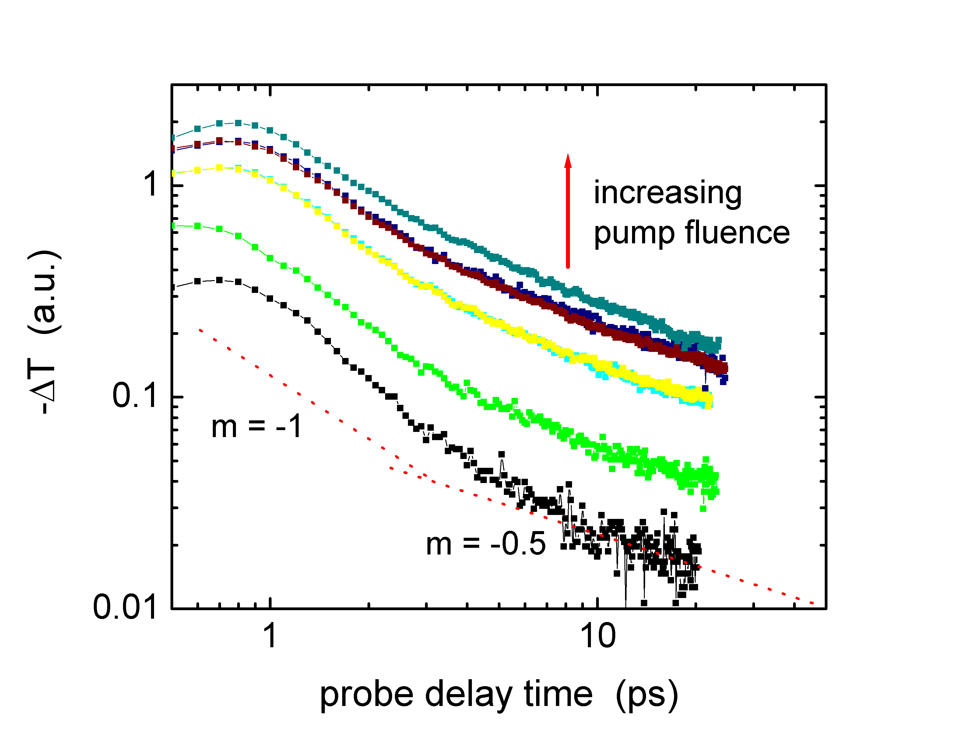
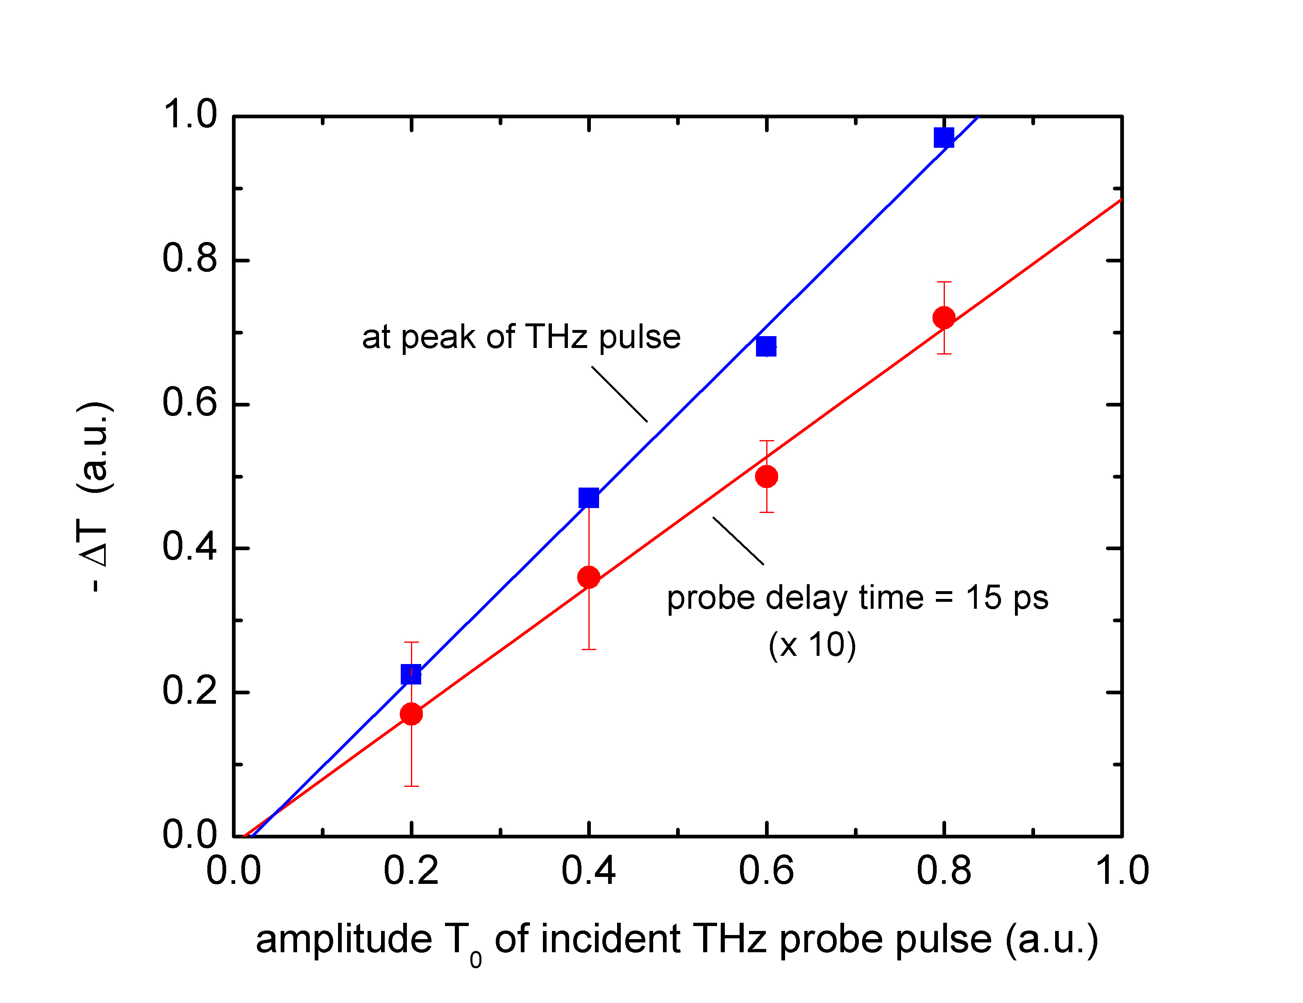
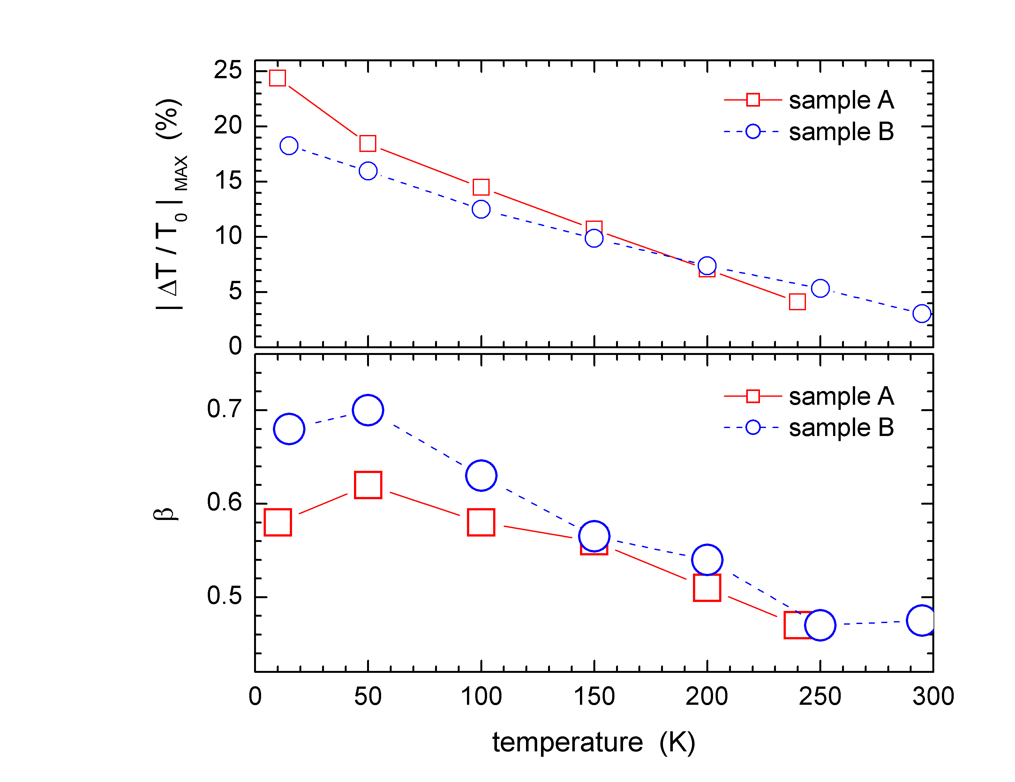
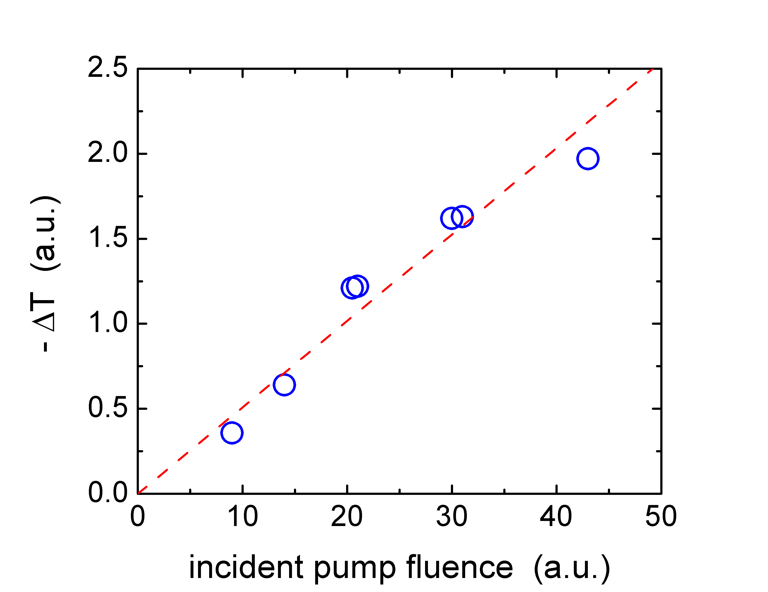
Figure 7(c) shows that the differential transmission signal –ΔT varies linearly with the amplitude of the electric field of the THz probe pulse. This means that the normalized differential transmission –ΔT/T₀ is independent of the magnitude of the THz pulse electric field, which eliminates the possibility that the electric field of the THz pulse itself may have some effect on the charge generation process such as electric-field-induced dissociation of excitons. However, the magnitude of the THz pulse electric field at the sample is less than 1 kV/cm, which is rather low compared to the fields used in many of the polymer studies that reported electric-field-induced dissociation of excitons into charge carriers.²⁶⁻³⁰ The dependence of the photoconducting signals on pump fluence is shown in Fig. 7(d). There is a slightly slower decay at higher pump fluences, which may be due in part to trap filling effects. In Fig. 7(e), the photoconducting signal is approximately linear with pump fluence, despite the fact that there is two-photon (or excited state) absorption in these samples when using 800 nm pump pulses. We are currently investigating the pump-fluence dependence of these samples further. We are also currently investigating the wavelength dependence of the transient photoconductivity in more detail, which will help in understanding the nature of the photoexcitation process.
(a)
(d)
(c)
(e)
(b)

Fig. 7. (a) Temperature dependence of the peak of the transient photoconductivity signal for two different TIPS pentacene single crystal samples. (b) Temperature dependence of the exponent β in the observed power-law decay t ^{–β} of the photoconducting signal at long times. (c) Dependence of the differential transmission signal of the THz probe pulse on the peak amplitude of the THz probe pulse at probe delay times corresponding to the peak of the photoconducting signal and 15 ps further away in the tail of the response. The observed linear dependence shows that the size of the electric field of the THz probe pulse does not influence the photocarrier generation process. (d) Pump fluence dependence of the transient photoconductivity dynamics at low temperature. The lines labeled “m = -1” and “m = -0.5” are guides to the eye for power-law decays of t ⁻¹ and t ^{-0.5}, respectively. (e) Corresponding peak photoconducting signal as a function of pump fluence.
5. PRELIMINARY RESULTS USING A FAST OSCILLOSCOPE

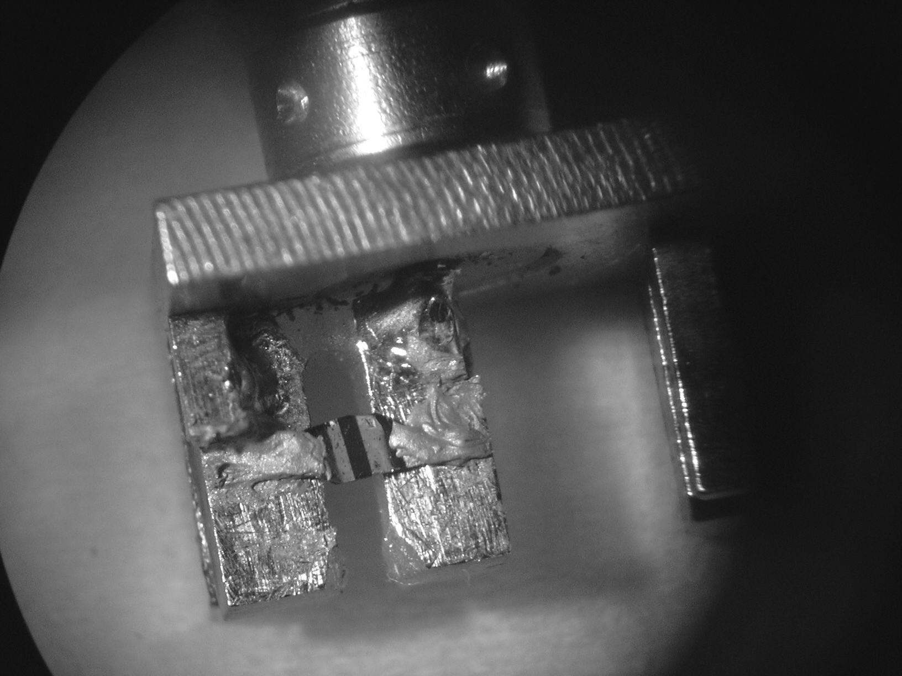
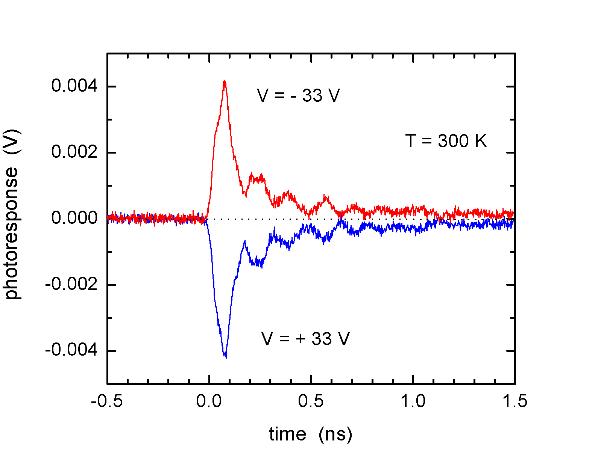
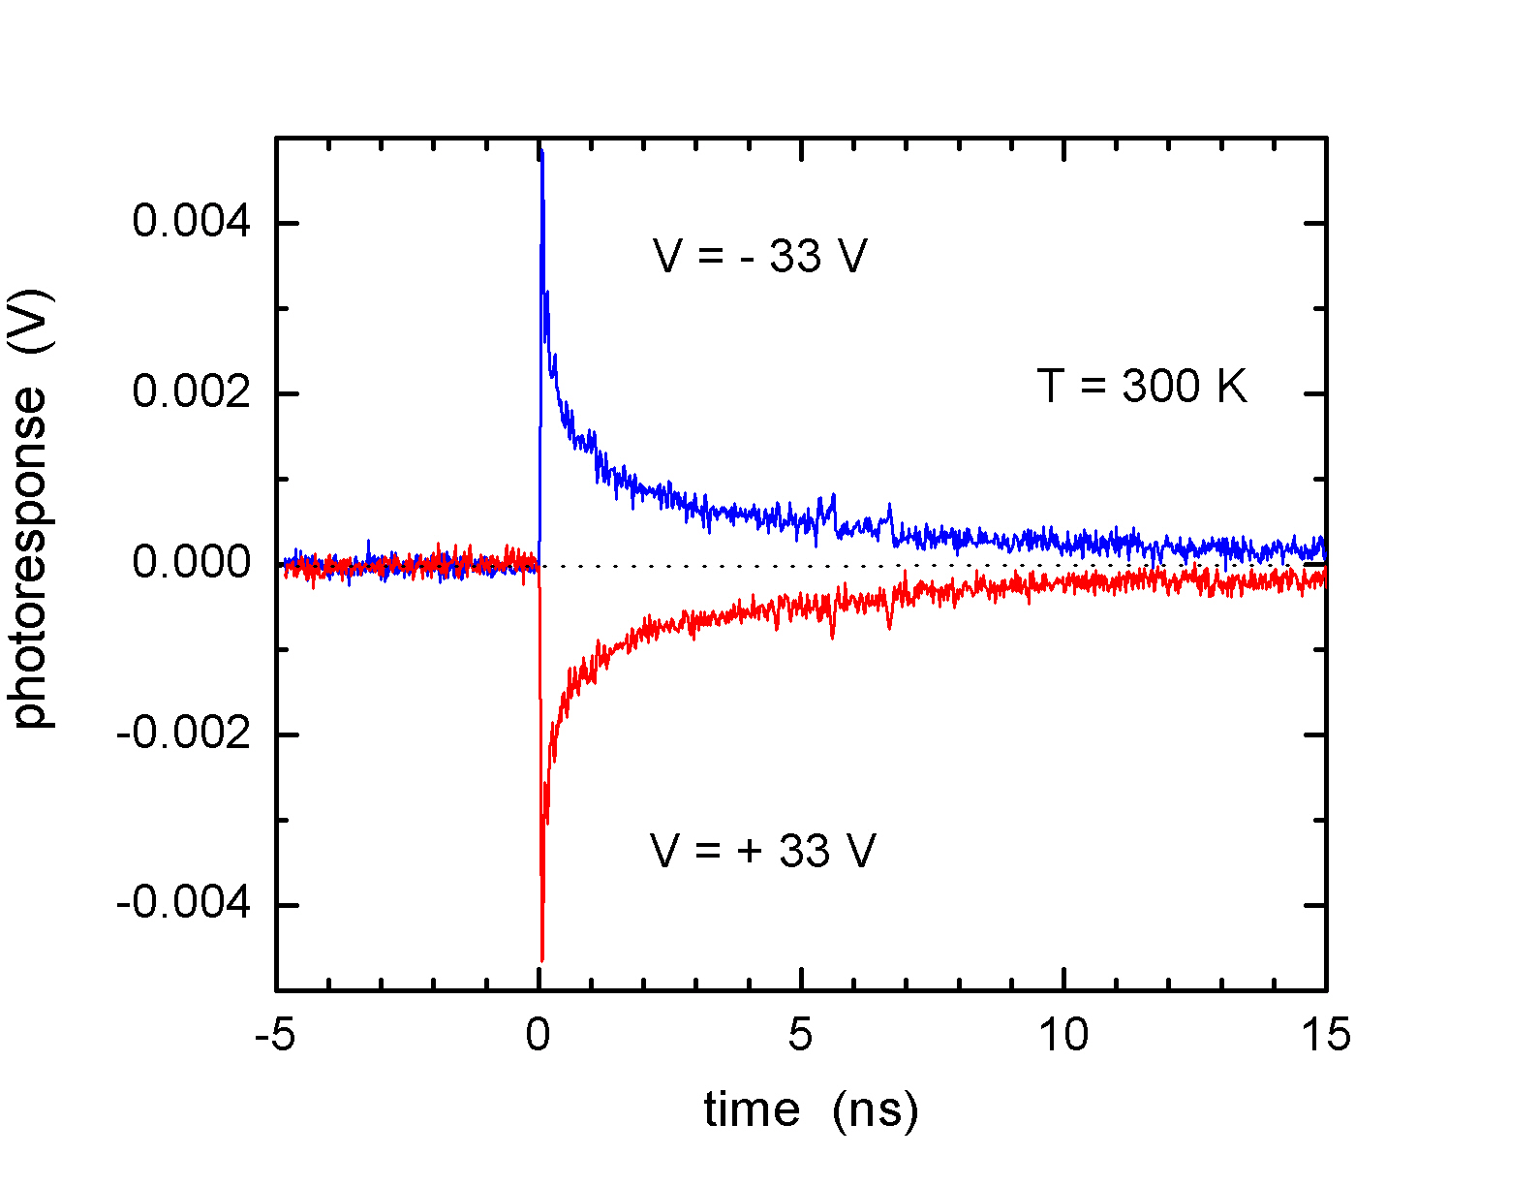
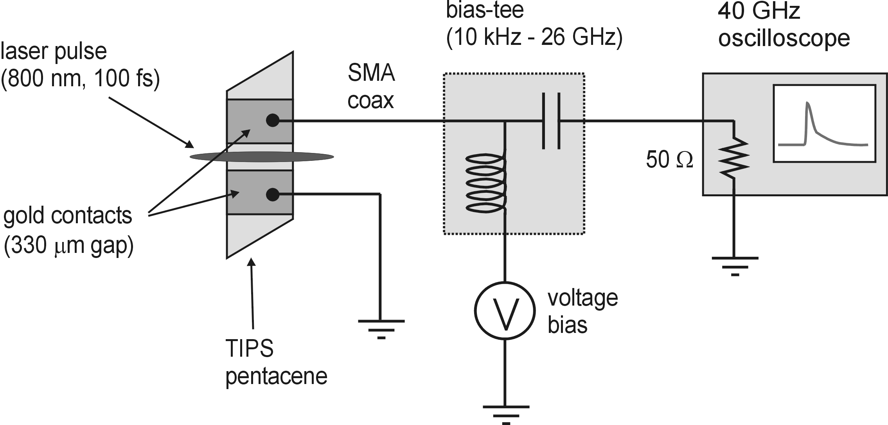
In order to examine relaxation dynamics at longer times and to study the effects of electric fields on the photogeneration process in TIPS pentacene crystals, we have recently performed a separate set of experiments that use contact-biased samples connected directly to a fast oscilloscope. The data presented here are preliminary results only. In these new studies, gold electrodes were first deposited through a shadow mask onto the ab-plane surface of TIPS pentacene single crystals. The separation between the electrodes is about 0.3 mm. As shown in Fig. 8(a), a single crystal sample is then attached to a PC board sample holder using conductive epoxy from which the photocurrent signal is launched into a SMA connector. Voltage bias is applied through a bias-tee, as illustrated in Fig. 8(b). A high-speed (40 GHz) digital sampling oscilloscope is used to measure the transient photocurrent generated in the device when it is excited by 800 nm, 100 fs pulses from our amplified Ti:sapphire laser source. Due to the sample mount design and SMA cables, the overall system rise time is about 50 ps. Figures 8(c) and 8(d) are some preliminary examples of photocurrent transients obtained in these experiments, which show that the carrier dynamics extends well into the nanosecond range. Further details on these experiments will be reported elsewhere.
(a)
(d)
(b)
(c)

Fig. 8. (a) Image of a TIPS pentacene crystal with gold contacts bonded to a SMA connector sample mount. The electrode separation is about 0.3 mm. (b) Schematic of the circuit used to measure the high-speed photocurrent transients. The bias-tee allows an external voltage bias to be applied across the gold contacts of the sample. The overall system rise time is about 50 ps. (c) Example of a photocurrent signal obtained at room temperature. (d) Example of a photocurrent signal obtained at room temperature from a different TIPS pentacene single crystal sample.
6. SUMMARY

In summary, we have used terahertz pulses to probe transient photoconductivity in functionalized pentacene single crystals with sub-picosecond time resolution. The rapid onset of the photoconducting signal suggests that mobile charge carriers are a primary photoexcitation. A lower estimate for the transient carrier mobility in TIPS pentacene single crystals of about 1.6 cm²/Vs at 10 K and 0.2 cm²/Vs at 300 K was obtained. A power-law decay for long time delays beyond 600 ps was also observed. Finally, we have demonstrated the potential of terahertz pulse spectroscopy as a noncontact technique for studying the nature of photoexcitations and ultrafast dynamics of mobile charge carriers in organic semiconductors.

ACKNOWLEDGEMENTS

This work was supported by NSERC, CFI, IIPP, ASRA, CIPI, iCORE, and ONR. O.O. acknowledges support from a Killam Memorial Postdoctoral Fellowship. We also wish to thank S. Parkin for supplying the figures of the functionalized pentacene crystal structure.

REFERENCES

- S. F. Nelson, Y.-Y. Lin, D. J. Gundlach, and T. N. Jackson, “Temperature-independent transport in high-mobility pentacene transistors”, Appl. Phys. Lett. 72, 1854 (1998).
- H. Klauk, D. J. Gundlach, and T. N. Jackson, "Fast organic thin-film transistor circuits", IEEE Electron Device Lett. 20, 289 (1999).
- C. D. Dimitrakopoulos and P. R. L. Malenfant, “Organic thin film transistors for large area electronics”, Adv. Mater. 14, 99 (2002).
- H. Klauk, M. Halik, U. Zschieschang, F. Eder, G. Schmid, and C. Dehm, “Pentacene organic transistors and ring oscillators on glass and on flexible polymeric substrates”, Appl. Phys. Lett. 82, 4175 (2003).
- V. Podzorov, V. M. Pudalov, and M. E. Gershenson, “Field-effect transistors on rubrene single crystals with parylene gate insulator”, Appl. Phys. Lett. 82, 1739 (2003).
- V. Y. Butko, X. Chi, and A. P. Ramirez, “Free-standing tetracene single crystal field effect transistor”, Solid State Commun. 128, 431 (2003).
- R. W. I. de Boer, T. M. Klapwijk, and A. F. Morpurgo, “Field-effect transistors on tetracene single crystals”, Appl. Phys. Lett. 83, 4345 (2003).
- R. W. I. de Boer, M. Jochemsen, T. M. Klapwijk, A. F. Morpurgo, J. Niemax, A. K. Tripathi, and J. Pflaum, “Space charge limited transport and time of flight measurements in tetracene single crystals: A comparative study”, J. Appl. Phys. 95, 1196 (2004).
- W. Warta, R. Stehle, and N. Karl, "Ultrapure, high-mobility organic photoconductors", Appl. Phys. A 36, 163 (1985).
- N. Karl (Chapters 6 and 8) in R. Farchioni and G. Grosso (Eds.), Organic Electronic Materials: Conjugated Polymers and Low Molecular weight Organic Solids, Springer-Verlag, Berlin, 2001.
- M. Pope and C. E. Swenberg, Electron Processes in Organic Crystals, 2nd Ed., Oxford University Press, New York, 1999.
- E. A. Silinsh and V. Cápek, Organic Molecular Crystals: Interaction, Localization, and Transport Phenomena, American Institute of Physics, New York, 1994.
- E. A. Silinsh, A. Klimkans, S. Larsson, and V. Cápek, "Molecular polaron states in polyacene crystals. Formation and transfer processes", Chem. Phys. 198, 311 (1995).
- R. H. Friend, R. W. Gymer, A. B. Holmes, J. H. Burroughes, R. N. Marks, C. Taliani, D. D. C. Bradley, D. A. Dos Santos, J. L. Brédas, M. Lögdlund, and W. R. Salaneck, "Electroluminescence in conjugated polymers", Nature 397, 121 (1999).
- A. Hepp, H. Heil, W. Weise, M. Ahles, R. Schmechel, and H. von Seggern, “Light-emitting field-effect transistor based on a tetracene thin film”, Phys. Rev. Lett. 91, 157406 (2003).
- V. G. Kozlov, V. Bulovic, P. E. Burrows, and S. R. Forrest, "Laser action in organic semiconductor waveguide and double-heterostructure devices", Nature 389, 362 (1997).
- G. A. Turnbull, P. Andrew, W. L. Barnes, and I. D. W. Samuel, “Operating characteristics of a semiconducting polymer laser pumped by a microchip laser”, Appl. Phys. Lett. 82, 313 (2003).
- S. E. Shaheen, C. J. Brabec, N. S. Sariciftci, F. Padinger, T. Fromherz, and J. C. Hummelen, “2.5% efficient organic plastic solar cells”, Appl. Phys. Lett. 78, 841 (2001).
- P. Peumans, A. Yakimov, and S. R. Forrest, “Small molecular weight organic thin film photodetectors and solar cells”, J. Appl. Phys. 93, 3693 (2003).
- P. Peumans, V. Bulovic, and S. R. Forrest, “Efficient, high-bandwidth organic multilayer photodetectors”, J. Appl. Phys. 93, 3693 (2003).
- S. S. Kim, Y. S. Choi, K. Kim, and S. Im, “Fabrication of p-pentacene/n-Si organic photodiodes and characterization of their photoelectric properties”, Appl. Phys. Lett. 82, 639 (2003).
- R. Koeppe, J. G. Müller, J. M. Lupton, J. Feldman, U. Scherf, and U. Lemmer, “One- and two-photon photocurrents from tunable organic microcavity photodiodes”, Appl. Phys. Lett. 82, 2601 (2003).
- N. S. Sariciftci (Ed.), Primary Photoexcitations in Conjugated Polymers: Molecular Exciton versus Semiconductor Band Model, World Scientific, Singapore, 1997.
- B. Kraabel, V. I. Klimov, R. Kohlman, S. Xu, H.-L. Wang, and D. W. McBranch, “Unified picture of the photoexcitations in phenylene-based conjugated polymers: universal spectral and dynamical features in subpicosecond transient absorption”, Phys. Rev. B 61, 8501 (2000).
- F. A. Hegmann, “Ultrafast carrier dynamics in conjugated polymers and organic molecular crystals”, Physics in Canada 59, 127 (2003).
- R. Kersting, U. Lemmer, M. Deussen, H. J. Bakker, R. F. Mahrt, H. Kurz, V. I. Archipov, H. Bässler, and O. E. Göbel, "Ultrafast field-induced dissociation of excitons in conjugated polymers", Phys. Rev. Lett. 73, 1440 (1994).
- W. Graupner, G. Cerullo, G. Lanzani, M. Nisoli, E. J. W. List, G. Leising, and S. De Silvestri, "Direct observation of ultrafast field-induced charge generation in ladder-type poly(para-phenylene)", Phys. Rev. Lett. 81, 3259 (1998).
- V. Gulbinas, Y. Zaushitsyn, V. Sundström, D. Hertel, H. Bässler, and A. Yartsev, "Dynamics of electric-field assisted charge carrier photogeneration in ladder-type poly(para-phenylene) at low excitation intensity", Phys. Rev. Lett. 89, 107401 (2002).
- J. G. Müller, U. Lemmer, J. Feldman, and U. Scherf, "Precursor states for charge carrier generation in conjugated polymers probed by ultrafast spectroscopy", Phys. Rev. Lett. 88, 147401 (2002).
- L. Lüer, H.-J. Egelhaaf, D. Oelkrug, C. Gadermaier, G. Cerullo, and G. Lanzani, “Charge carrier photogeneration in oligo(phenylenevinylene) thin films: A quantitative study”, Phys. Rev. B 68, 155313 (2003).
- S. V. Frolov, Ch. Kloc, B. Batlogg, M. Wohlgenannt, X. Jiang, and Z. V. Vardeny, “Excitation dynamics in single molecular crystals of α-hexathiophene from femtoseconds to milliseconds”, Phys. Rev. B 63, 205203 (2001).
- D. Moses, A. Dogariu, and A. J. Heeger, "Ultrafast detection of charged photocarriers in conjugated polymers", Phys. Rev. B 61, 9373 (2000).
- P. B. Miranda, D. Moses, and A. J. Heeger, "Ultrafast photogeneration of charged polarons in conjugated polymers", Phys. Rev. B 64, 08120(R) (2001).
- F. A. Hegmann, R. R. Tykwinski, K. P. H. Lui, J. E. Bullock, and J. E. Anthony, “Picosecond transient photoconductivity in functionalized pentacene molecular crystals probed by terahertz pulse spectroscopy”, Phys. Rev. Lett. 89, 227403 (2002).
- V. K. Thorsmolle, R. D. Averitt, X. Chi, D. J. Hilton, D. L. Smith, A. P. Ramirez, and A. J. Taylor, “Ultrafast conductivity dynamics in pentacene probed using terahertz spectroscopy”, Appl. Phys. Lett. 84, 891 (2004).
- D. Moses, “Charge quantum yield and transient transport properties of anthracene and amorphous selenium”, Solid State Commun. 69, 721 (1989).
- D. Moses, J. Wang, A. Dogariu, D. Fichou, and C. Videlot, “Carrier dynamics in α-octithiophene solids: comparison of the transient photoconductivity and excited-state absorption in single-crystal and polycrystalline film”, Phys. Rev. B 59, 7715 (1999).
- A. G. Manoj, A. A. Alagiriswamy, and K. S. Narayan, “Photogenerated charge carrier transport in p-polymer n-polymer bilayer structures”, J. Appl. Phys. 94, 4088 (2003).
- A. Tapponnier, I. Biaggio, M. Koehler, and P. Günter, “Integrated pulsed photoconductivity of organic light-emitting diodes”, Appl. Phys. Lett. 83, 5473 (2003).
- For a review, see M. C. Nuss and J. Orenstein, “Terahertz Time-Domain Spectroscopy”, in Millimeter and Submillimeter Wave Spectroscopy of Solids, Ed. G. Grüner, Springer, Berlin, 1998.
- For a more recent overview of THz pulse techniques, see D. Mittleman (Ed.), Sensing with Terahertz Radiation, Springer-Verlag, Berlin, 2003.
- M. Walther, K. Jensby, S. Keiding, H. Takahashi, and H. Ito, “Far-infrared properties of DAST”, Opt. Lett. 25, 911 (2000).
- T.-I. Jeon, D. Grischkowsky, A. K. Mukherjee, and R. Menon, “Electrical and optical characterization of conducting poly-3-methylthiophene film by THz time-domain spectroscopy”, Appl. Phys. Lett. 79, 4142 (2001).
- T.-I. Jeon, K.-J. Kim, C. Kang, S.-J. Oh, J.-H. Son, K. H. An, D. J. Bae, and Y. H. Lee, “Terahertz conductivity of anisotropic single walled carbon nanotube films”, Appl. Phys. Lett. 80, 3403 (2002).
- M. C. Beard, G. M. Turner, and C. A. Schmuttenmaer, “Measuring intramolecular charge transfer via coherent generation of THz radiation”, J. Phys. Chem. A 106, 878 (2002).
- J. J. Carey, R. T. Bailey, D. Pugh, J. N. Sherwood, F. R. Cruickshank, and K. Wynne, “Terahertz pulse generation in an organic crystal by optical rectification and resonant excitation of molecular charge transfer”, Appl. Phys. Lett. 81, 4335 (2002).
- C. Soci and D. Moses, “Terahertz generation from poly(p-phenylene vinylene) photoconductive antenna”, Synth. Metals 139, 815 (2003).
- M. C. Beard, G. M. Turner, and C. A. Schmuttenmaer, “Transient photoconductivity in GaAs as measured by time-resolved terahertz spectroscopy”, Phys. Rev. B 62, 15764 (2000).
- M. Schall and P. Uhd Jepsen, “Photoexcited GaAs surfaces studied by transient terahertz time-domain spectroscopy”, Opt. Lett. 25, 13 (2000).
- S. S. Prabhu, S. E. Ralph, M. R. Melloch, E. S. Harmon, “Carrier dynamics of low-temperature-grown GaAs observed via THz spectroscopy”, Appl. Phys. Lett. 70, 2419 (1997).
- M.C. Beard, G.M. Turner, and C.A. Schmuttenmaer, “Subpicosecond carrier dynamics in low-temperature grown GaAs as measured by time-resolved terahertz spectroscopy”, J. Appl. Phys. 90, 5915 (2001).
- K. P. H. Lui and F. A. Hegmann, “Ultrafast carrier relaxation in radiation-damaged silicon-on-sapphire studied by optical-pump-terahertz-probe experiments”, Appl. Phys. Lett. 78, 3478 (2001). F. A. Hegmann and K. P. H. Lui, “Optical pump-terahertz probe investigation of carrier relaxation in radiation-damaged silicon-on-sapphire”, Proc. SPIE 4643, 31 (2002). K. P. H. Lui and F. A. Hegmann, “Fluence- and temperature-dependent studies of carrier dynamics in radiation-damaged silicon-on-sapphire and amorphous silicon”, J. Appl. Phys. 93, 9012 (2003).
- J. Shan, F. Wang, E. Knoesel, M. Bonn, and T. Heinz, “Measurement of the frequency-dependent conductivity in sapphire”, Phys. Rev. Lett. 90, 247401 (2003).
- J. E. Anthony, J. S. Brooks, D. L. Eaton, and S. R. Parkin, “Functionalized pentacene: improved electronic properties from control of solid-state order”, J. Am. Chem. Soc. 123, 9482 (2001).
- J. E. Anthony, D. L. Eaton, and S. R. Parkin, “A road map to stable, soluble, easily crystallized pentacene derivatives”, Org. Lett. 4, 15 (2002).
- T. Tokumoto, J. S. Brooks, R. Clinite, X. Wei, J. E. Anthony, D. L. Eaton, and S. R. Parkin, “Photoresponse of the conductivity in functionalized pentacene compounds”, J. Appl. Phys. 92, 5208 (2002).
- C. D. Sheraw, T. N. Jackson, D. L. Eaton, and J. E. Anthony, “Functionalized pentacene active layer organic thin-film transistors”, Adv. Mater. 15, 2009 (2003).
- R. C. Haddon, X. Chi, M. E. Itkis, J. E. Anthony, D. L. Eaton, T. Siegrist, C. C. Mattheus, and T. T. M. Palstra, “Band electronic structure of one- and two-dimensional pentacene molecular crystals”, J. Phys. Chem. B 106, 8288 (2002).

